# VISVESVARAYA TECHNOLOGICAL UNIVERSITY

  **"Jnana Sangama", Belgavi**

**(Academic Year 2022-2023)**

**An Project Report on**

**“Water Potability”**

Submitted in fulfillment of the Internship

**BACHELOR OF ENGINEERING**

**IN**

**ARTIFCIAL INTELLIGENCE & MACHINE LEARNING**

**Submitted By:**

**ABHISHEK GADGE (3RB20AI002)**

**Under the guidance of:**

 **Mr. Abhishek Sali**

**BHEEMANNA KHANDRE INSTITUTE OF TECHNOLOGY**

**ARTIFICIAL INTELLIGENCE AND MACHINE LEARNING**

**S. V. E. Society's**

**Bheemanna Khandre Institute of Technology, Bhalki 585328   
Artificial Intelligence and Machine Learning**



**CERTIFICATE**

This is to certify that the project entitled “Water potability” has been successfully carried out by ABHISHEK GADGE(3RB20AI002) fulfillment of the completion of Internship in e- learning labs in Data analytics, during the academic year 2022-2023. It is certified that all corrections/suggestions for the Bachelor of Engineering Degree.

**Internship Guide Head of Dept**

**Mr. Abhishek sali Dr. Shivkumar A.**

**Signiture with date**

**_________________**

**_________________**

ACKNOWLEDGEMENTS

We would like to express our gratitude to the following people whose constant support helped immensely in the successful completion of our Internship.

We are grateful to all those who have helped us in preparing our project.

Our sincere thanks to our project guide **Mr. Riyaz** **Bhagban** for their guidance in the preparation of the project. Their constant and sincere guidance helped us in maintaining the tempo and thus helped us to complete the Internship.

We wish to express our sincere thanks **Dr. Shivkumar A. (H.O.D Dept of AIML)** and whole of the Artificial Intelligence & Machine Learning for the constant encouragement during the completion of the Internship.

We would like to thank **Dr. N. M. Biradar,** principal, BKIT Bhalki, for providing such a congenial working environment.

Finally we thank all our friends for their help in making our project a grand success.

# Cordinally

ABHISHEK GADGE

Abstract

Access to safe and potable drinking water is a fundamental human right and a critical public health concern. In this data-driven project, we leverage data science techniques to evaluate and predict the potability of water from diverse sources. The objective of this study is to develop a robust predictive model that can aid in the rapid assessment of water quality, thereby facilitating informed decisions for water treatment and distribution.the project resulted in our data science approach has yielded promising results in predicting water potability. The developed models exhibit high accuracy and robustness in identifying potable and non-potable water sources. Additionally, we have identified key physicochemical parameters that significantly influence water quality, offering valuable insights for water quality management.

# 

**TABLE OF CONTENTS-**

| **Sl.no** | **Chapter** | **Page No.** |
| --- | --- | --- |
| **1** | Introduction | 6-7 |
| **2** | Aim | 8-9 |
| **3** | Methodology | 10 |
| **4** | Analysis of dataset | 11 |
| **5** | Result | 12 |
| **6** | CSV FILE | 13-14 |
| **7** | JPEG FILE | 15 |
| **8** | SAV FILE | 16 |
| **9** | PY FILE | 17-18 |
| **10** | PIPELINE FILE | 19-27 |
| **11** | Potable water analysis file | 28-47 |
| **12** | Water quality prediction file | 48-60 |

**CHAPTER-1**

**Introduction**

* Access to safe and clean drinking water is a fundamental human right and a cornerstone of public health. However, ensuring the potability of water sources is a complex and multifaceted challenge. In this era of data-driven decision-making, harnessing the power of data analytics and exploratory data analysis (EDA) presents a promising avenue for assessing and improving water potability.
* This report presents the findings and insights gained from a comprehensive study on water potability using EDA techniques. Our project aims to address critical questions related to water quality, source viability, and the identification of factors that impact the safety of drinking water. By conducting a thorough examination of water quality data, we seek to contribute to the enhancement of water management and the protection of public health.
* Background
* Ensuring water potability involves evaluating various physicochemical and chemical parameters of water samples from diverse sources such as rivers, lakes, and wells. Traditional methods for assessing water quality have limitations in terms of timeliness and accuracy. This is where data analytics and EDA step in, offering the potential to expedite and refine the process of determining water potability.
* Project Objectives
* Our project's primary objectives are as follows:
* Data Collection: Gather a comprehensive dataset containing water quality measurements from various sources.
* Exploratory Data Analysis (EDA): Employ EDA techniques to uncover patterns, trends, correlations, and anomalies in the water quality dataset.
* Insights Generation: Identify key physicochemical parameters that significantly influence water potability and generate actionable insights.
* Modeling: Develop predictive models for water potability based on EDA findings, enabling rapid assessment and decision-making.
* Recommendations: Provide recommendations for water treatment facilities, policymakers, and communities to improve water quality and safety.
* Structure of the Report
* This report is organized as follows:
* Data Collection and Preprocessing: We detail the process of data collection, cleaning, and preparation for analysis.
* Exploratory Data Analysis: This section presents the EDA techniques employed and highlights the discovered insights.
* Modeling and Predictive Analysis: We describe the development of predictive models based on EDA findings.
* Recommendations and Implications: This section provides actionable recommendations and discusses the broader implications of our findings.
* Conclusion: We summarize the key takeaways from the project and discuss its significance.
* In an era where data is abundant and its potential applications are vast, our project showcases how data analytics, particularly EDA, can serve as a powerful tool for addressing real-world challenges such as water potability. We believe that the insights presented in this report can inform evidence-based decision-making, improve water quality management practices, and contribute to safeguarding the health and well-being of communities reliant on clean drinking water sources.

**CHAPTER-2**

**Aim**

* The aim of a water potability data science project using Exploratory Data Analysis (EDA) is to gain a deep understanding of the dataset related to water quality and potability and to prepare the data for further analysis and modeling. EDA serves as a crucial initial step in any data science project and can help achieve several objectives:

1. \***\*Data Understanding**\*\*: EDA allows you to comprehend the structure and contents of the dataset. You can explore the variables, their data types, and their distributions.

2. \*\***Data Quality Assessment**\*\*: You can assess the quality of the data by identifying missing values, outliers, or errors. Cleaning and preprocessing the data is essential to ensure that subsequent analyses and models are based on high-quality data.

3. \*\***Feature Selection**\*\*: EDA can help you determine which features (variables) are relevant for predicting water potability. You can identify features that have strong correlations with the target variable and might be useful for modeling.

4. \*\***Outlier Detection**\*\*: EDA helps in identifying and handling outliers that can adversely affect the performance of machine learning models.

5. \*\***Class Imbalance**\*\*: If the dataset suffers from class imbalance (e.g., a disproportionate number of potable vs. non-potable samples), EDA can provide insights into the severity of the imbalance and help in selecting appropriate techniques to address it.

6. \*\***Visualization**\*\*: EDA often involves creating visualizations such as histograms, box plots, heatmaps, and scatter plots to reveal patterns, relationships, and

anomalies in the data. These visualizations can convey insights to stakeholders and guide further analysis.

7. \*\***Correlation Analysis**\*\*: EDA can uncover correlations between features and the target variable. Understanding these relationships can guide the selection of appropriate machine learning algorithms and feature engineering strategies.

8. \*\***Data Preprocessing**\*\*: EDA helps in deciding how to handle missing data, encode categorical variables, and standardize or normalize features.

9. \*\***Hypothesis Generation**\*\*: EDA can lead to the formulation of hypotheses about the factors affecting water potability. These hypotheses can be tested using statistical methods or machine learning models.

10. \*\***Data Exploration Report**\*\*: EDA often results in a report summarizing key findings, visualizations, and data quality issues. This report serves as a foundation for subsequent phases of the project and is essential for effective communication with stakeholders.

In summary, the primary aim of a water potability data science project using EDA is to thoroughly understand the data, prepare it for modeling, and identify potential insights and challenges. EDA sets the stage for subsequent tasks such as feature engineering, model selection, and predictive modeling, ultimately contributing to informed decision-making in the context of water quality and potability.

**CHAPTER-3**

**Methodology**

**Collecting Data**:

The first step is to collect the data that will be used for the analysis. This data can be obtained from a variety of sources, such as:well, borewell, river.

**Cleaning the data**:

Cleaning the data by removing duplicate rows ,filling in missing values & correcting errors in the data.

**Explore the data:**

Once the data has been cleaned, it is important to explore it to get a better understanding of the data. This can be done by usingstatistical methods to describe the data and by visualizing the data using graphs and charts

**Choose the analytical methods:**

the analytical methods that will be used to analyze the data. This will depend on the specific goals of the analysis

**Analyze the data:**

Once the data has been analyzed, the results need to be interpreted. This can involve explaining what the results mean and how they can be used to answer the research questions.

**Interpret the results:**

Once the analytical methods have been chosen, the data can be analyzed. This can involve running statistical tests, creating visualizations, or developing machine learning models.

**CHAPTER-4**

**Analysis of Dataset**

**Ph** - The pH of most drinking-water lies within the range 6.5–8.5.

Hardness - Below 75 mg/L - is generally considered soft. 76 to 150 mg/L - moderately hard. 151 to 300 mg/L - hard. More than 300 mg/ - very hard.

**Solids** - A high concentration of total solids will make drinking water unpalatable and might have an adverse effect on people who are not used to drinking such water.

**Chloramines** - Chloramines are disinfectants used to treat drinking water. Chloramine levels up to 4 milligrams per liter (mg/L) or 4 parts per million (ppm) are considered safe in drinking water.

**Sulfate**- Sulfate in drinking water currently has a secondary maximum contaminant level (SMCL) of 250 milligrams per liter (mg/L), based on aesthetic effects (i.e., taste and odor).

**Conductivity**- Electrical conductivity measures the ability of water to conduct an electrical current. The higher the concentration of dissolved charged chemicals (also known as salts) in the water, the greater the electrical current that can be conducted.

**Organic_carbon**-Organic carbon is naturally present in nearly every water source. Low, stable levels of TOC are not cause for concern and simply indicate that decaying vegetation and organic matter are present. 1 Abnormal changes to TOC measurements may indicate that water treatment processes will require adjustment.

**Trihalomethane’s** - (THMs) are a byproduct of the water treatment process. They are formed when natural organic material, such as the decaying vegetation commonly found in lakes and reservoirs, reacts with chlorine used to treat the water.

**Turbidity**-Turbidity is a measurement of how cloudy the water is in a lake or river. Anything that makes water cloudy will increase turbidity. High turbidity can be caused by silt, mud, algae, plant pieces, melting glaciers, sawdust, wood ashes or chemicals in the water.

**CHAPTER-5**

**Result -**

The water fit to c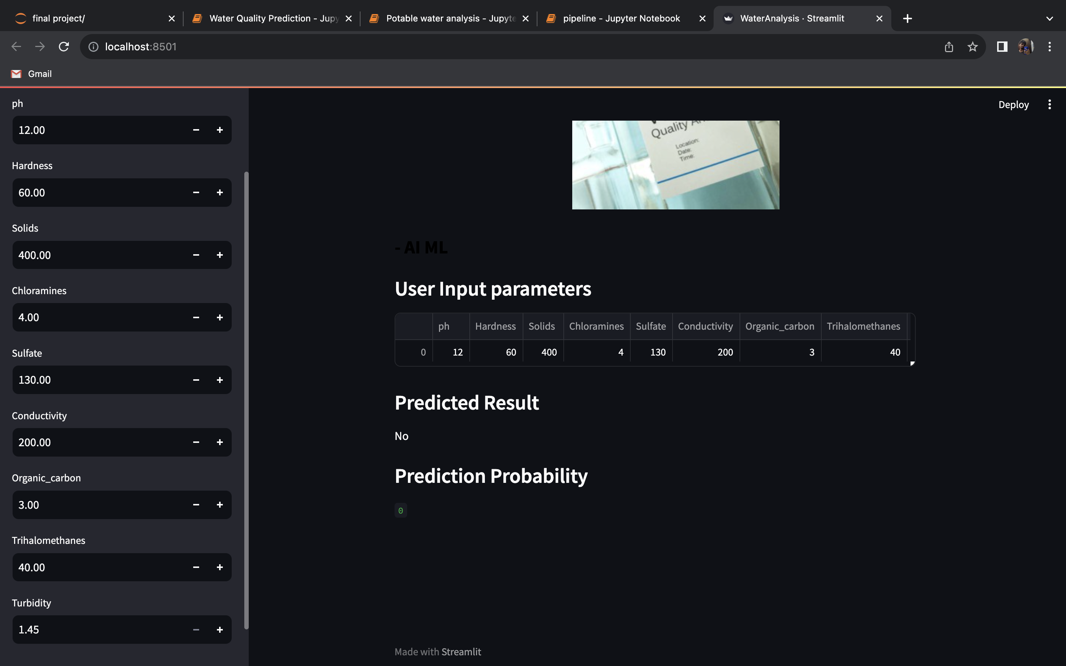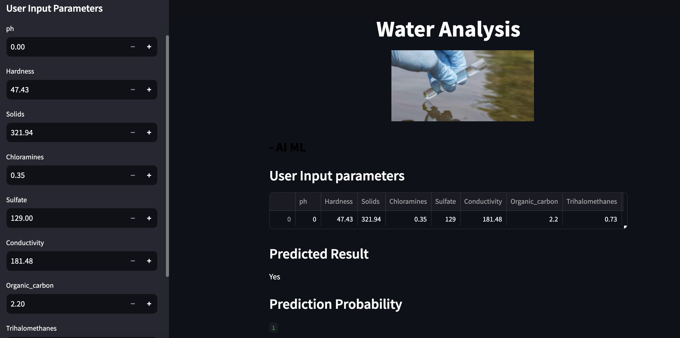onsume-

The water unfit to consume -

**CHAPTER-6**

**CSV FILE**

CSV stands for Comma-Separated Values. It is a plain text file format that is used to store tabular data, such as spreadsheets or databases.

In a CSV file, each line represents a row of data, and each value within a line is separated by a comma. The first line of the file often contains the column headers, indicating the names of the different fields or attributes.

CSV files are widely used because they are simple and easy to understand. They can be created and edited using various software applications, including spreadsheet programs like Microsoft Excel or Google Sheets. CSV files can be imported into or exported from different software systems, making them a common format for data exchange between different applications.

water_potability csv file-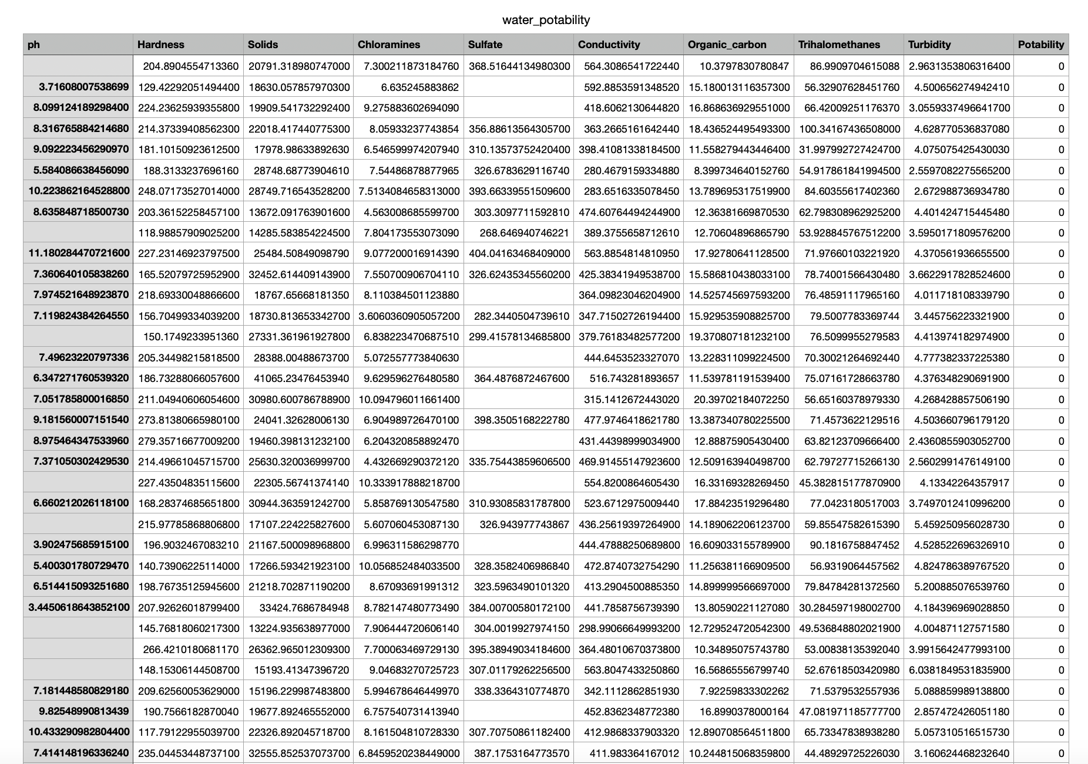

Data for clean water (in csv format)-

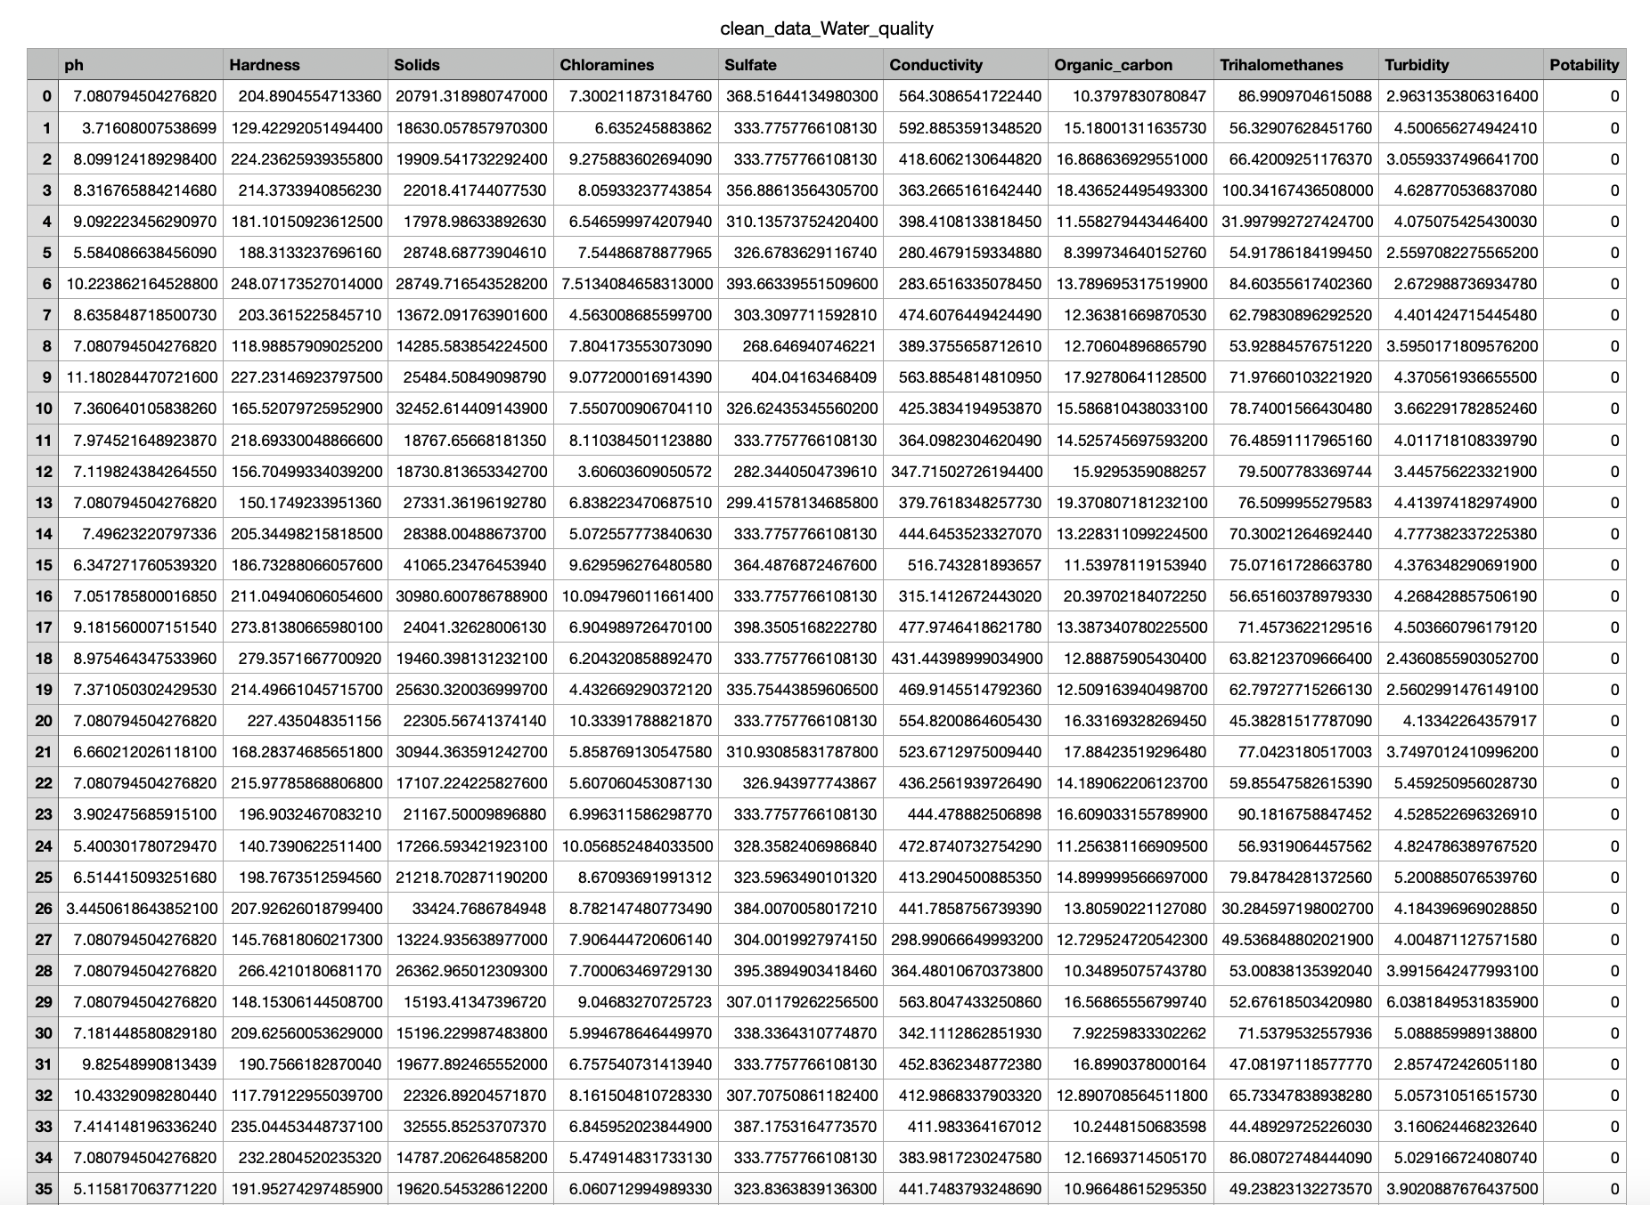

**CHAPTER-7**

**JPEG FILE**

JPG (or JPEG) is a commonly used file format for storing digital images. It stands for Joint Photographic Experts Group, the organization that developed the format. JPG files use a lossy compression method, which means that some image data is discarded in order to reduce file size. This compression can result in a slight loss of image quality, but it allows for smaller file sizes, making it easier to store and share images on the internet. JPG files are widely supported by various devices, software, and platforms, making them a popular choice for digital photography and web graphics.

The jpg files are the image files ,presently there are two image files those are water.jpg and image.jpg ,respectively.

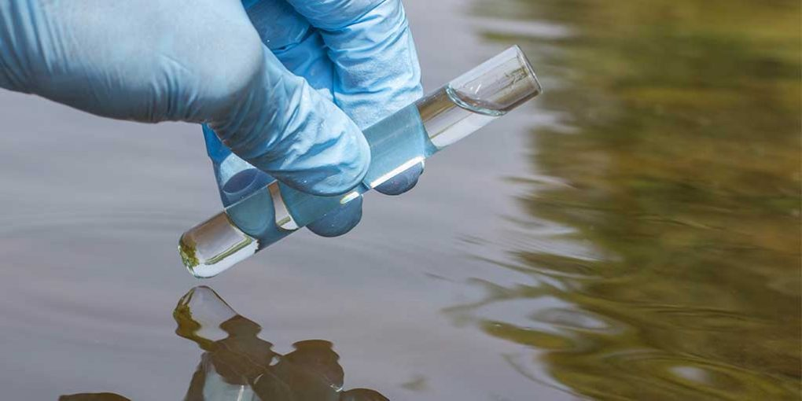

**CHAPTER-8**

**SAV FILE**

A .sav file is a file format used for saving and loading machine learning models in Python. It is commonly used with the scikit-learn library, which provides a function called "joblib.dump()" to save a trained model as a .sav file. This file can then be loaded using the "joblib.load()" function to reuse the model for prediction or further training. The .sav file stores the model's parameters, weights, and other necessary information to recreate the model's state.

The ".sav" file extension typically refers to a saved model file in machine learning or statistical modeling. It is commonly used in Python programming language with libraries like scikit-learn or TensorFlow.

When training a machine learning model, it is common to save the trained model to a file for later use or deployment. This file contains the trained parameters and information about the model architecture, allowing it to be loaded and used without retraining.

The ".sav" file format is specific to the library or framework used to save the model. For example, in scikit-learn, the joblib library is commonly used to save models as ".sav" files. In TensorFlow, the ".sav" file format is not used, and instead, models are saved as ".pb" (protobuf) files or in the SavedModel format.

Overall, a ".sav" file is a saved model file that can be loaded and used for prediction or further analysis without the need to retrain the model.

**CHAPTER-9**

**PY FILE**

**Code (WaterAnalysis.py)**-

import streamlit as st

import pandas as pd

import pickle

from PIL import Image

st.markdown("<h1 style='text-align: center; color: greeen;'>Water Analysis</h1>", unsafe_allow_html=True)

image = Image.open('water.jpg')

col1, col2, col3 = st.columns(3)

with col1:

st.write('')

with col2:

st.image(image,width=280 )

with col3:

st.write('')

st.markdown("<h1 style='text-align: centre; color: black; font-size: 25px';>- AI ML</h1>", unsafe_allow_html=True)

st.sidebar.header('User Input Parameters')

def user_input_features()

ph = st.sidebar.number_input('ph',min_value=0.00,max_value=14.00,step=0.01)

Hardness = st.sidebar.number_input('Hardness',min_value=47.43,max_value=323.12,step=0.01)

Solids = st.sidebar.number_input('Solids',min_value=321.94,max_value=61227.19,step=0.01)

Chloramines = st.sidebar.number_input('Chloramines',min_value=0.35,max_value=13.12,step=0.01)

Sulfate = st.sidebar.number_input('Sulfate',min_value=129.00,max_value=481.03,step=0.01)

Conductivity = st.sidebar.number_input('Conductivity',min_value=181.48,max_value=753.34,step=0.01)

OC = st.sidebar.number_input("Organic_carbon",min_value=2.20,max_value=28.30,step=0.01)

Trihalomethanes = st.sidebar.number_input('Trihalomethanes',min_value=0.73,max_value=124.0,step=0.01)

Turbidity = st.sidebar.number_input('Turbidity',min_value=1.45,max_value=6.73,step=0.1)

user_input = {

'ph': ph,

'Hardness': Hardness,

'Solids': Solids,

'Chloramines': Chloramines,

'Sulfate': Sulfate,

'Conductivity': Conductivity,

'Organic_carbon':OC,

'Trihalomethanes':Trihalomethanes,

'Turbidity':Turbidity

}

features = pd.DataFrame(user_input,index = [0])

return features

df = user_input_features()

st.subheader('User Input parameters')

st.write(df)

with open(file="model.sav",mode="rb") as f1:

model = pickle.load(f1)

prediction = model.predict(df)

prediction_proba = model.predict_proba(df)

st.subheader('Predicted Result')

st.write('Yes' if prediction_proba[0][1] > 0.5 else 'No')

st.subheader('Prediction Probability')

st.write(prediction[0])

**CHAPTER-10**

**PIPELINE FILE**

The term "pipeline.ipynb" typically refers to a Jupyter Notebook file (with a ".ipynb" extension) that contains code and documentation for creating and using a data pipeline in Python. In the context of data science and machine learning, a data pipeline is a series of data processing steps and transformations that are applied to raw data to prepare it for analysis or machine learning tasks. Jupyter Notebook is a popular tool for developing and documenting such data pipelines because it allows you to combine code, explanations, and visualizations in a single interactive document.

It contains -

* **Data Loading**: Code for importing raw data from various sources such as CSV files, databases, APIs, or other data formats.
* **Data** **Preprocessing**: This section includes code for cleaning, transforming, and manipulating the data. Common preprocessing steps might include handling missing values, encoding categorical variables, scaling features, and more.
* **Exploratory** **Data** **Analysis** (EDA): Code and visualizations that explore the dataset to gain insights into its structure, relationships, and patterns. EDA is crucial for understanding the data before building machine learning models.
* **Feature** **Engineering**: Code for creating new features or selecting relevant features that can improve model performance.
* **Model** **Building**: Code for training machine learning models using the preprocessed data. This section might include model selection, hyperparameter tuning, and evaluation metrics.
* **Model** **Deployment** (Optional): If the notebook is part of a larger workflow, it might include code for deploying the trained model for use in a production environment.
* **Documentation** **and** **Explanations**: Text cells that provide explanations, comments, and insights into the code and data transformations performed. This helps make the notebook more understandable and accessible to others.
* **Visualizations**: Charts, graphs, and plots that illustrate key findings or data distributions.

The code used in pipeline is as follows -

* **Input -**

import pandas as pd

import numpy as np

import matplotlib.pyplot as plt

import seaborn as sns

import plotly.express as px

* **Explanation-**

Here's a brief description of each library:

1. `pandas` (imported as `pd`): Pandas is a powerful library for data manipulation and analysis. It provides data structures like DataFrames and Series that make it easy to work with structured data.

2. `numpy` (imported as `np`): NumPy is a library for numerical computations in Python. It provides support for working with arrays and matrices, which is useful for various mathematical and scientific tasks.

3. `matplotlib.pyplot` (imported as `plt`): Matplotlib is a popular library for creating static, animated, and interactive visualizations in Python. The `pyplot` module provides a simple interface for creating plots and charts.

4. `seaborn` (imported as `sns`): Seaborn is a data visualization library built on top of Matplotlib. It provides a high-level interface for creating aesthetically pleasing statistical graphics.

5. `plotly.express` (imported as `px`): Plotly is a library for creating interactive and web-based visualizations. Plotly Express is a simplified high-level interface for creating a wide range of interactive plots and charts.

With these libraries, we will have a powerful set of tools for data analysis and visualization in Python. Depending on our specific project or analysis needs, you can use these libraries to manipulate data, create various types of plots and charts, and visualize your findings.

* **Input-**

df = pd.read_csv('clean_data_Water_quality.csv')

df =df.iloc[:,1:]

* **Explanation -**

Let me explain each step:

1. `pd.read_csv('clean_data_Water_quality.csv')`: This line of code reads the data from the CSV file 'clean_data_Water_quality.csv' and loads it into a Pandas DataFrame. By default, the first row of the CSV file is assumed to contain column headers, so they will become the column names in the DataFrame.

2. `df.iloc[:,1:]`: This line of code uses the `.iloc` indexer to select all rows (indicated by `:`) and all columns starting from the second column (index 1) to the end. Essentially, it removes the first column (index 0) from the DataFrame.

Input -

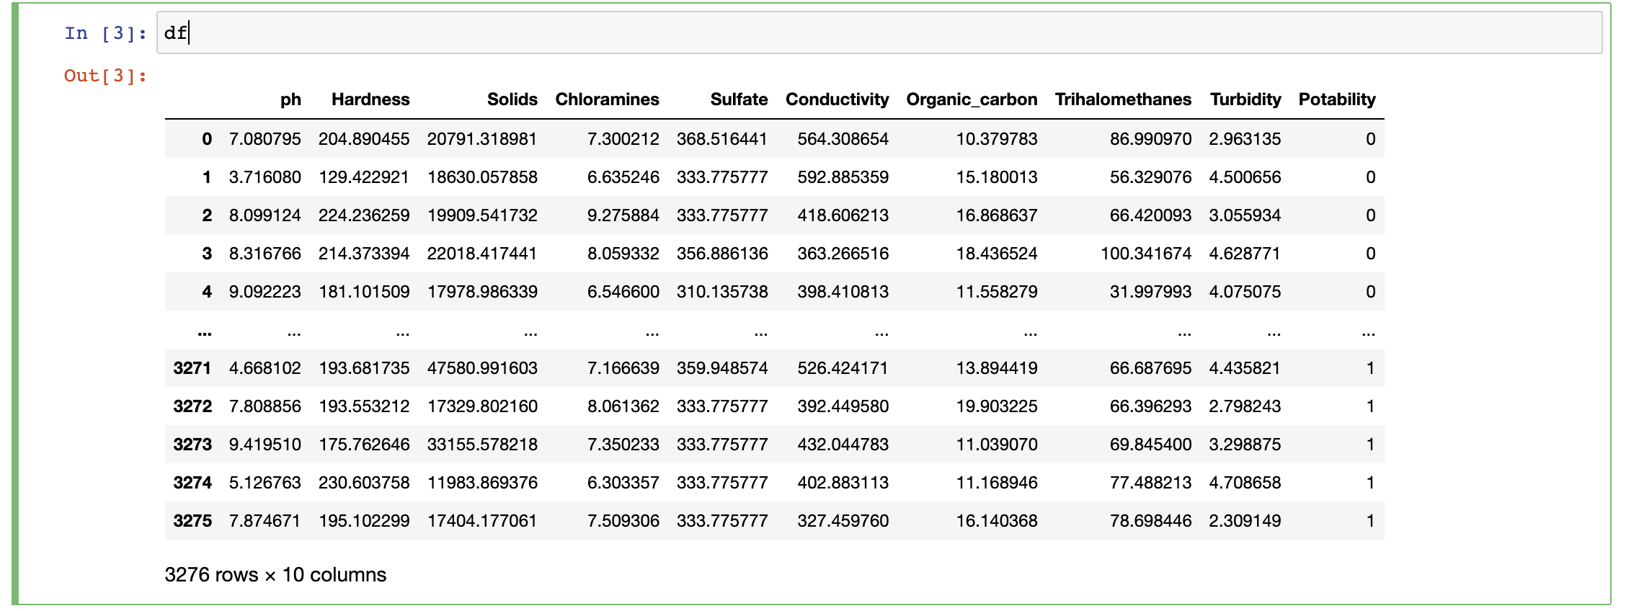

**Explanation** -

We are printing the value present in variable ‘df’ .

Input -

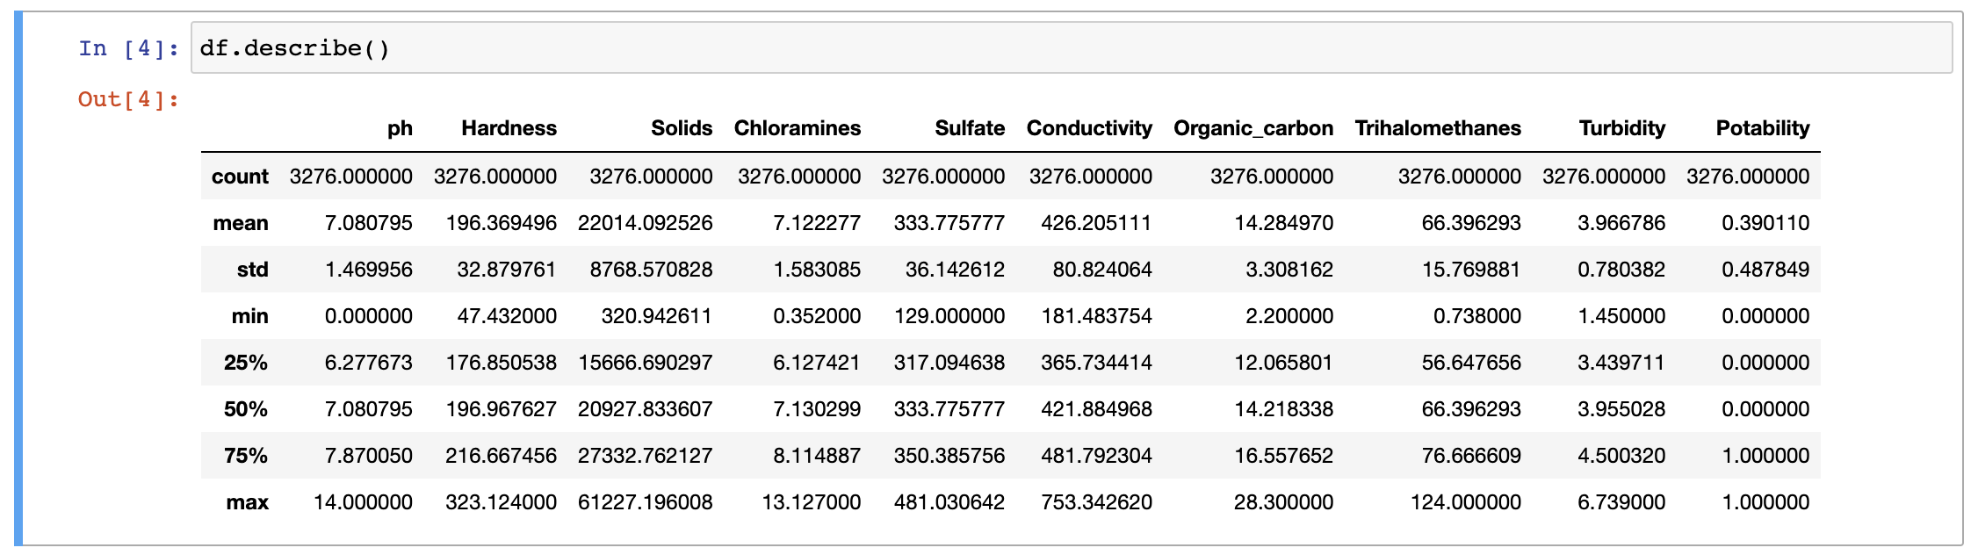

**Explanation** -

The df.describe() method is used to generate descriptive statistics of a DataFrame, such as count, mean, standard deviation, minimum, and maximum values, as well as percentiles. It provides a summary of the numerical columns in the DataFrame .

When you run this code, it will return a DataFrame with statistics for each numerical column in your original DataFrame df. The resulting DataFrame will include information like the count (number of non-null values), mean, standard deviation, minimum, 25th percentile, median (50th percentile), 75th percentile, and maximum for each numerical column in your data. This summary is useful for gaining a quick overview of the distribution and central tendencies of your data.

**Input**-

from sklearn.pipeline import Pipeline

from sklearn.ensemble import RandomForestClassifier

from sklearn.preprocessing import StandardScaler

**Explanation**-

* Pipeline: The Pipeline class in scikit-learn allows you to create a sequence of data preprocessing steps and a final estimator (model) that is applied sequentially. Pipelines are useful for streamlining the machine learning workflow, as they encapsulate multiple steps into a single object.
* RandomForestClassifier: This is an implementation of the Random Forest classifier, which is an ensemble learning method for classification tasks. It creates a forest of decision trees and combines their predictions to make more accurate and robust predictions.
* StandardScaler: Standardization is a common preprocessing step in machine learning, and StandardScaler is used to scale and center numerical features to have a mean of 0 and a standard deviation of 1. This is often important for certain machine learning algorithms that are sensitive to feature scales.

You can use these modules to build a machine learning pipeline that includes data preprocessing with StandardScaler and a classification model with RandomForestClassifier.

* **Input-**

classifier = []

classifier.append(('standardize', StandardScaler()))

classifier.append((“model",RandomForestClassifier()))

**Explanation**-

You are defining a machine learning pipeline using a list called classifier. Here's a brief explanation:

* Standardization Step ('standardize')
  + You are adding a step to standardize the data using StandardScaler(). Standardization ensures that all features have a mean of 0 and a standard deviation of 1, which can be important for certain machine learning algorithms.
* Modeling Step ('model')
  + You are adding another step to the pipeline, which involves using the RandomForestClassifier() as your machine learning model. The RandomForestClassifier is an ensemble learning method for classification tasks.

By creating this pipeline, you can apply these two steps sequentially. First, the data is standardized, and then the random forest classifier is applied to the standardized data. This is a common practice in machine learning to ensure consistent preprocessing of data before modeling.

* **Input-**

X = df.drop('Potability', axis=1)

y = df.Potability

* **Explanation-**

We are preparing your data for a machine learning task, typically a classification task. Let me explain what these two lines do:

* X = df.drop('Potability', axis=1):
  + Here, you are creating a new DataFrame X by dropping the 'Potability' column from your original DataFrame df. This line effectively separates your feature variables (independent variables) from the target variable (dependent variable). The axis=1 argument specifies that you want to drop a column (as opposed to a row), and 'Potability' is the name of the column you want to exclude.
* y = df.Potability:
  + In this line, you are creating a Series y which contains the values of the 'Potability' column from your original DataFrame df. This Series typically represents the target variable or the labels you want to predict. y will contain the values that you want your machine learning model to learn and predict.

After running these two lines, you'll have X as your feature matrix (all columns from df except 'Potability') and y as your target variable (the 'Potability' column). You can then use X and y to train and evaluate machine learning models. Typically, X will contain the input features, and y will contain the corresponding labels or target values you are trying to predict.

**Input**-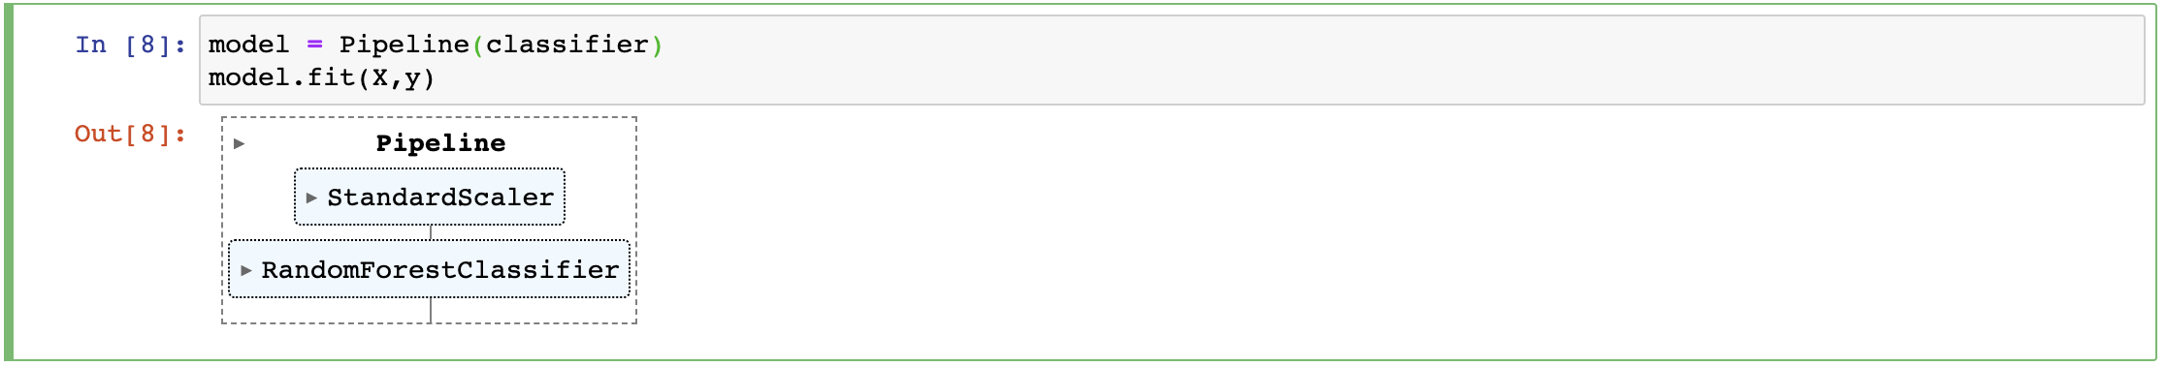

**Explanation**-

You are creating a machine learning pipeline named model and then fitting (training) it on your feature matrix X and target variable y. Let's break down what each line does:

* model = Pipeline(classifier):
  + Here, you create a machine learning pipeline named model by passing the classifier list to the Pipeline constructor. As explained earlier, the classifier list defines the steps of the pipeline, including feature standardization and the random forest classifier.
* model.fit(X, y):
  + - This line fits (trains) the model pipeline on your data. Specifically:
    - X is your feature matrix, which contains all the input features.
    - y is your target variable, which contains the corresponding labels or target values you are trying to predict.

After running these two lines, the model pipeline will have been trained on your data. This means it has learned a predictive model that can make predictions based on new data. You can use this trained model to make predictions on new, unseen data using the model.predict() method or perform other evaluation and analysis tasks as needed for your machine learning project.

* **Input-**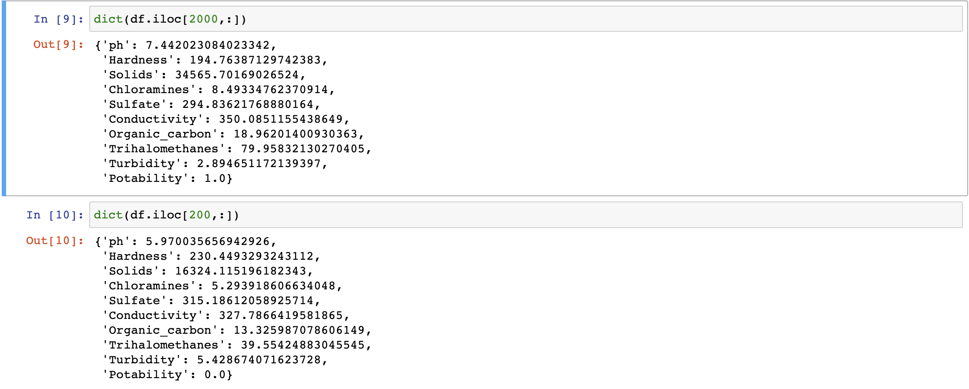
* **Explanation-**

After running these code snippets, row_2000_dict will contain the data from the 2000th row of your DataFrame df as a dictionary, and row_200_dict will contain the data from the 200th row as a dictionary.

You can access individual values from these dictionaries using the column names as keys.

* **Input-**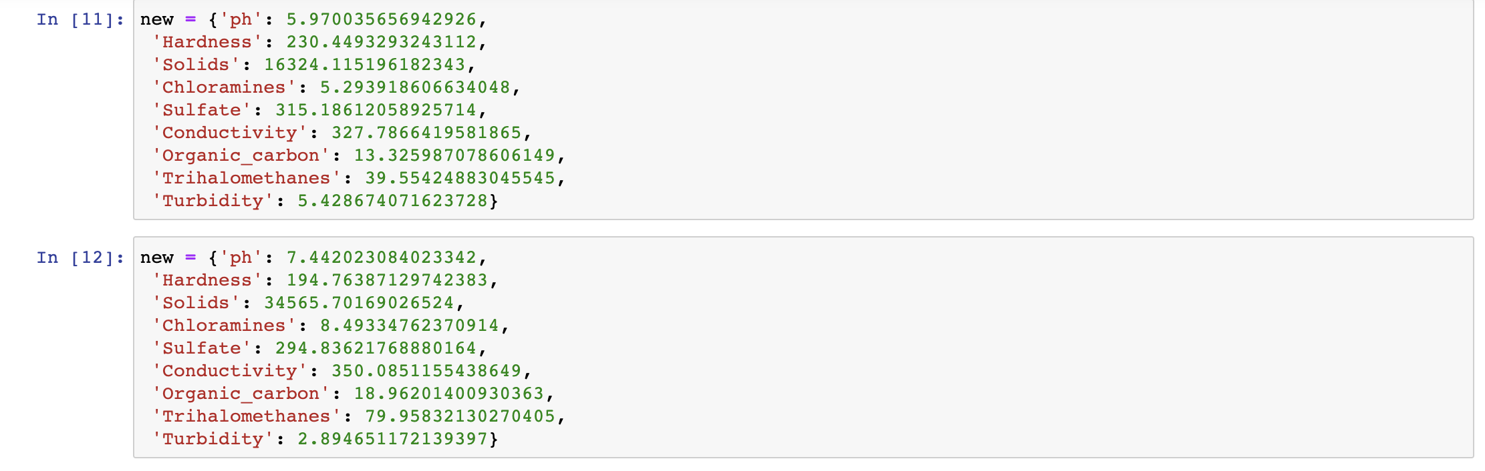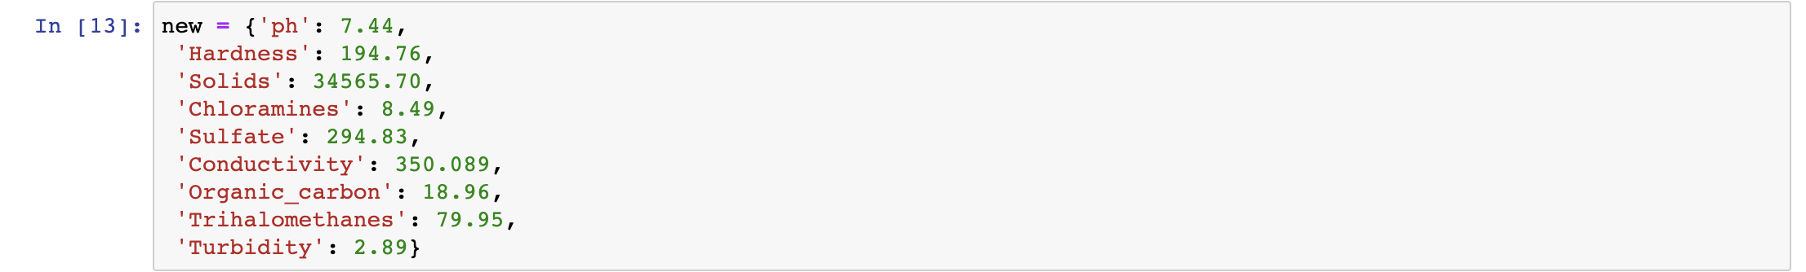
* **Explanation-**

We have provided three dictionaries, each containing different sets of numerical values. These dictionaries seem to represent data related to water quality parameters.

* **Input-**

data = pd.DataFrame(new,index = [0])

* **Explanation-**

This code creates a DataFrame named data with one row of data based on the dictionary new_data. The index=[0] argument specifies that this data corresponds to the first row of the DataFrame.

You can repeat a similar process to create DataFrames for the other dictionaries by replacing new_data with the appropriate dictionary.

* **Input-**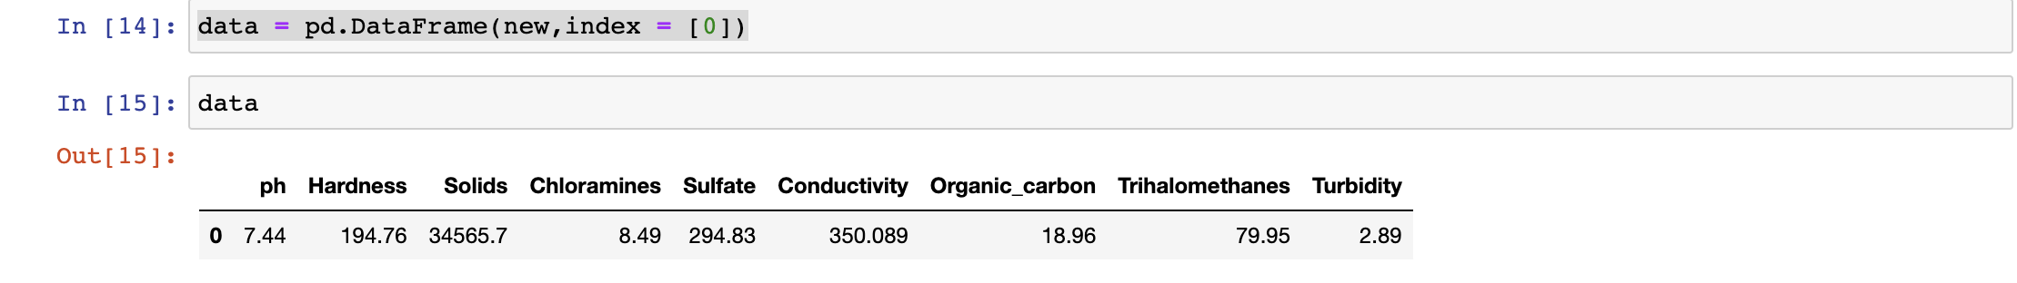
* **Explanation-**

It contains the numerical values from the first dictionary with column names corresponding to the keys in the dictionary. This DataFrame represents a single row of data with various water quality parameters

* **Input-**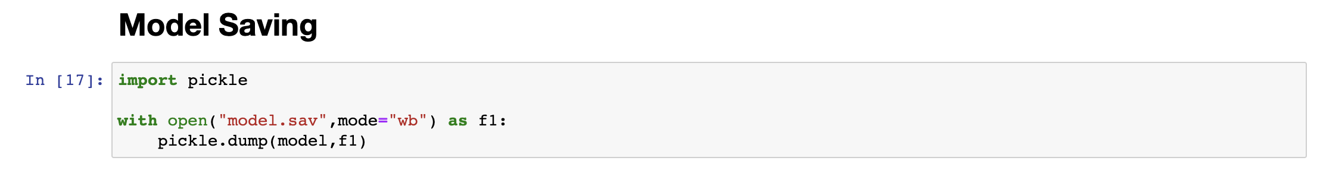
* **Explanation-**

It appears that you are using the pickle module in Python to save (serialize) a machine learning model, named model, to a file named "model.sav." This is a common way to save trained models for later use or sharing with others. Here's an explanation of your code:

1.import pickle

This line imports the pickle module, which provides a way to serialize and deserialize Python objects.

2.with open("model.sav", mode="wb") as f1:

You open a file named "model.sav" in binary write mode ("wb"), indicating that you want to write binary data to this file.

3.pickle.dump(model, f1)

* Here, you use the pickle.dump() function to serialize and save the model object to the file "model.sav." The model object, which is your machine learning pipeline, is written to the file as a binary representation.

After executing this code, your model will be saved to the "model.sav" file, and you can load it later using pickle to make predictions on new data without having to retrain the model from scratch. To load the model back into memory, you can use the pickle.load() function.

**CHAPTER-11**

**Potable water analysis file**

* **Input-**

import pandas as pd

import numpy as np

import matplotlib.pyplot as plt

import seaborn as sns

import plotly.express as px

df = pd.read_csv('water_potability.csv')

df

df.info()

df.isnull().sum()

plt.figure(figsize = (10, 8))

sns.heatmap(df.corr(), annot = True)

sns.countplot(x = 'Potability', data = df, saturation = 0.8)

plt.xticks(ticks = [0, 1], labels = ['Not Potable', 'Potable'])

plt.show()

df.hist(figsize=(18,10))

plt.show()

df.corr()['Potability']

df.hist(column = 'Hardness', by = 'Potability')

px.box(df, x=df.Potability, y=df.ph, color=df.Potability, width=600, height=400)

px.box(df, x=df.Potability, y=df.Hardness, color=df.Potability, width=600, height=400)

px.box(df, x=df.Potability, y=df.Solids, color=df.Potability, width=600, height=400)

px.pie(df, names=df.Potability, hole=0.4)

px.scatter(df, x=df.ph, y=df.Sulfate, color=df.Potability, template='plotly_dark', trendline=‘ols')

* **Explanation-**

The code you provided is a series of data manipulation and visualization operations using Python libraries such as pandas, numpy, matplotlib, seaborn, and plotly.

Here is a breakdown of each line of code:

1. `import pandas as pd`: Importing the pandas library under the alias "pd".

2. `import numpy as np`: Importing the numpy library under the alias "np".

3. `import matplotlib.pyplot as plt`: Importing the matplotlib.pyplot module under the alias "plt" for data visualization.

4. `import seaborn as sns`: Importing the seaborn library under the alias "sns" for statistical data visualization.

5. `import plotly.express as px`: Importing the plotly.express module under the alias "px" for interactive visualizations.

6. `df = pd.read_csv('water_potability.csv')`: Reading a CSV file named 'water_potability.csv' into a pandas DataFrame and assigning it to the variable "df".

7. `df`: Printing the contents of the DataFrame "df" to see the data.

8. `df.info()`: Displaying information about the DataFrame, including the number of rows, columns, and data types of each column.

9. `df.isnull().sum()`: Counting the number of missing values in each column of the DataFrame "df" using the `.isnull()` and `.sum()` methods.

10. `plt.figure(figsize = (10, 8))`: Creating a new figure with a width of 10 and height of 8 for the following visualizations.

11. `sns.heatmap(df.corr(), annot = True)`: Creating a heatmap of the correlation matrix of the DataFrame "df" using seaborn's `.heatmap()` function, with annotations enabled.

12. `sns.countplot(x = 'Potability', data = df, saturation = 0.8)`: Creating a count plot of the 'Potability' column in the DataFrame "df" using the `.countplot()` function from seaborn, with a saturation level of 0.8.

13. `plt.xticks(ticks = [0, 1], labels = ['Not Potable', 'Potable'])`: Setting custom x-axis tick locations and labels for the count plot.

14. `plt.show()`: Displaying the count plot.

15. `df.hist(figsize=(18,10))`: Creating histograms for each numerical column in the DataFrame "df" using the `.hist()` method, with a figure size of 18 width and 10 height.

16. `plt.show()`: Displaying the histograms.

17. `df.corr()['Potability']`: Calculating the correlation coefficients between the 'Potability' column and each numerical column in the DataFrame "df".

18. `df.hist(column = 'Hardness', by = 'Potability')`: Creating separate histograms for the 'Hardness' column in the DataFrame "df" based on the different values in the 'Potability' column.

19. `px.box(df, x=df.Potability, y=df.ph, color=df.Potability, width=600, height=400)`: Creating a box plot using plotly's `px.box()` function for comparing the distribution of 'ph' values based on the different values in the 'Potability' column, with different colors for each category.

20. `px.box(df, x=df.Potability, y=df.Hardness, color=df.Potability, width=600, height=400)`: Creating a box plot for comparing the distribution of 'Hardness' values based on the different values in the 'Potability' column.

21. `px.box(df, x=df.Potability, y=df.Solids, color=df.Potability, width=600, height=400)`: Creating a box plot for comparing the distribution of 'Solids' values based on the different values in the 'Potability' column.

22. `px.pie(df, names=df.Potability, hole=0.4)`: Creating a pie chart using plotly's `px.pie()` function to visualize the distribution of the 'Potability' values.

23. `px.scatter(df, x=df.ph, y=df.Sulfate, color=df.Potability, template='plotly_dark', trendline='ols')`: Creating a scatter plot using plotly's `px.scatter()` function to explore the relationship between 'ph' and 'Sulfate' values, with different colors for each value in the 'Potability' column, a dark template, and a trendline using ordinary least squares regression.

* **Input-**

df.isnull().sum()

df.isnull().mean().plot(kind = 'pie')

plt.title('Missing Data in Percentage')

plt.xlabel('Features')

plt.ylabel('Percentage of missing values')

df.ph = df.ph.fillna(df.ph.mean())

df.Sulfate = df.Sulfate.fillna(df.Sulfate.mean())

df.Trihalomethanes = df.Trihalomethanes.fillna(df.Trihalomethanes.mean())

df.isnull().sum()

import pandas as pd

df = pd.read_csv('clean_data_Water_quality.csv')

df

from sklearn.model_selection import train_test_split

X = df.drop(['Potability','Unnamed: 0'], axis=1)

y = df.Potability

X_train, X_test, y_train, y_test = train_test_split(X, y, test_size = 0.2, random_state=101)

X

print(X_train.shape)

print(X_test.shape)

print(y_train.shape)

print(y_test.shape)

from sklearn.preprocessing import StandardScaler

sc = StandardScaler()

X_train = sc.fit_transform(X_train)

X_test = sc.transform(X_test)

* **Explanation-**

Starting from line 1, the code is performing data cleaning and preparation tasks for machine learning modeling using the sklearn library.

1. `df.isnull().sum()`: This line calculates the total number of missing values in each column of the DataFrame "df".

2. `df.isnull().mean().plot(kind = 'pie')`: This line creates a pie chart to visualize the percentage of missing values in each column of the DataFrame "df".

3. `plt.title('Missing Data in Percentage')`: This line sets the title of the pie chart.

4. `plt.xlabel('Features')`: This line sets the label for the x-axis of the pie chart.

5. `plt.ylabel('Percentage of missing values')`: This line sets the label for the y-axis of the pie chart.

6. `df.ph = df.ph.fillna(df.ph.mean())`: This line fills the missing values in the 'ph' column of the DataFrame "df" with the mean value of the column.

7. `df.Sulfate = df.Sulfate.fillna(df.Sulfate.mean())`: This line fills the missing values in the 'Sulfate' column of the DataFrame "df" with the mean value of the column.

8. `df.Trihalomethanes = df.Trihalomethanes.fillna(df.Trihalomethanes.mean())`: This line fills the missing values in the 'Trihalomethanes' column of the DataFrame "df" with the mean value of the column.

9. `df.isnull().sum()`: This line calculates the total number of missing values in each column of the DataFrame "df" after filling the missing values.

10. `import pandas as pd`: This line imports the pandas library under the alias "pd".

11. `df = pd.read_csv('clean_data_Water_quality.csv')`: This line reads a CSV file named 'clean_data_Water_quality.csv' into a pandas DataFrame and assigns it to the variable "df".

12. `df`: This line prints the contents of the DataFrame "df" to see the data.

13. `from sklearn.model_selection import train_test_split`: This line imports the `train_test_split` function from sklearn.model_selection module.

14. `X = df.drop(['Potability','Unnamed: 0'], axis=1)`: This line creates a new DataFrame "X" by dropping the 'Potability' and 'Unnamed: 0' columns from the DataFrame "df".

15. `y = df.Potability`: This line creates a Series "y" containing the values in the 'Potability' column of the DataFrame "df".

16. `X_train, X_test, y_train, y_test = train_test_split(X, y, test_size = 0.2, random_state=101)`: This line splits the data into training and testing sets using the `train_test_split` function, where X represents the features and y represents the target variable 'Potability'. The test set size is set to 0.2 (20%) of the data, and the random_state is set to 101 for reproducibility.

17. `X`: This line prints the contents of the DataFrame "X" to see the training set features.

18. `print(X_train.shape)`: This line prints the shape (number of rows and columns) of the X_train array.

19. `print(X_test.shape)`: This line prints the shape (number of rows and columns) of the X_test array.

20. `print(y_train.shape)`: This line prints the shape (number of elements) of the y_train array.

21. `print(y_test.shape)`: This line prints the shape (number of elements) of the y_test array.

22. `from sklearn.preprocessing import StandardScaler`: This line imports the StandardScaler class from the sklearn.preprocessing module for feature scaling.

23. `sc = StandardScaler()`: This line creates an instance of the StandardScaler class.

24. `X_train = sc.fit_transform(X_train)`: This line applies the fit_transform method of the StandardScaler instance to scale the X_train data.

25. `X_test = sc.transform(X_test)`: This line applies the transform method of the StandardScaler instance to scale the X_test data.

* **Input-**

from sklearn.linear_model import LogisticRegression

from sklearn.metrics import confusion_matrix,accuracy_score,classification_report

from sklearn.ensemble import RandomForestClassifier

from xgboost import XGBClassifier

from sklearn.neighbors import KNeighborsClassifier

from sklearn.naive_bayes import GaussianNB

model1 = LogisticRegression()

model1.fit(X_train,y_train)

y_pred1 = model1.predict(X_test)

accuracy_score(y_test,y_pred1)

confusion_matrix(y_test,y_pred1)

model2 = RandomForestClassifier()

model2.fit(X_train,y_train)

y_pred2 = model2.predict(X_test)

accuracy_score(y_test,y_pred2)

confusion_matrix(y_test,y_pred2)

model3 = XGBClassifier()

model3.fit(X_train, y_train)

y_pred3 = model3.predict(X_test)

cm = confusion_matrix(y_test, y_pred3)

accuracy_score(y_test, y_pred3)

confusion_matrix(y_test,y_pred3)

y_pred3 = model3.predict(X_test)

cm = confusion_matrix(y_test, y_pred3)

print(cm)

* **Explanation-**

The code above is performing machine learning modeling using different algorithms:

1. `from sklearn.linear_model import LogisticRegression`: This line imports the LogisticRegression class from the sklearn.linear_model module.

2. `from sklearn.metrics import confusion_matrix, accuracy_score, classification_report`: This line imports the confusion_matrix, accuracy_score, and classification_report functions from the sklearn.metrics module.

3. `from sklearn.ensemble import RandomForestClassifier`: This line imports the RandomForestClassifier class from the sklearn.ensemble module.

4. `from xgboost import XGBClassifier`: This line imports the XGBClassifier class from the xgboost module.

5. `from sklearn.neighbors import KNeighborsClassifier`: This line imports the KNeighborsClassifier class from the sklearn.neighbors module.

6. `from sklearn.naive_bayes import GaussianNB`: This line imports the GaussianNB class from the sklearn.naive_bayes module.

7. `model1 = LogisticRegression()`: This line creates an instance of the LogisticRegression model and assigns it to the variable "model1".

8. `model1.fit(X_train, y_train)`: This line fits the LogisticRegression model to the training data.

9. `y_pred1 = model1.predict(X_test)`: This line predicts the target variable "y" using the fitted LogisticRegression model on the test data and assigns the predictions to "y_pred1".

10. `accuracy_score(y_test, y_pred1)`: This line calculates the accuracy score by comparing the predicted labels "y_pred1" with the true labels "y_test".

11. `confusion_matrix(y_test, y_pred1)`: This line calculates a confusion matrix to evaluate the performance of the LogisticRegression model.

12. `model2 = RandomForestClassifier()`: This line creates an instance of the RandomForestClassifier model and assigns it to the variable "model2".

13. `model2.fit(X_train, y_train)`: This line fits the RandomForestClassifier model to the training data.

14. `y_pred2 = model2.predict(X_test)`: This line predicts the target variable "y" using the fitted RandomForestClassifier model on the test data and assigns the predictions to "y_pred2".

15. `accuracy_score(y_test, y_pred2)`: This line calculates the accuracy score by comparing the predicted labels "y_pred2" with the true labels "y_test".

16. `confusion_matrix(y_test, y_pred2)`: This line calculates a confusion matrix to evaluate the performance of the RandomForestClassifier model.

17. `model3 = XGBClassifier()`: This line creates an instance of the XGBClassifier model and assigns it to the variable "model3".

18. `model3.fit(X_train, y_train)`: This line fits the XGBClassifier model to the training data.

19. `y_pred3 = model3.predict(X_test)`: This line predicts the target variable "y" using the fitted XGBClassifier model on the test data and assigns the predictions to "y_pred3".

20. `cm = confusion_matrix(y_test, y_pred3)`: This line calculates a confusion matrix to evaluate the performance of the XGBClassifier model and assigns it to the variable "cm".

21. `accuracy_score(y_test, y_pred3)`: This line calculates the accuracy score by comparing the predicted labels "y_pred3" with the true labels "y_test".

22. `confusion_matrix(y_test, y_pred3)`: This line calculates a confusion matrix to evaluate the performance of the XGBClassifier model.

23. `y_pred3 = model3.predict(X_test)`: This line predicts the target variable "y" using the fitted XGBClassifier model on the test data and assigns the predictions to "y_pred3".

24. `cm = confusion_matrix(y_test, y_pred3)`: This line calculates a confusion matrix to evaluate the performance of the XGBClassifier model and assigns it to the variable "cm".

25. `print(cm)`: This line prints the confusion matrix "cm" to the console.

* **Input-**

accuracy_score(y_test, y_pred3)

confusion_matrix(y_test,y_pred3)

from imblearn.over_sampling import SMOTE

X_resampled, y_resampled = SMOTE().fit_resample(X, y)

from sklearn.model_selection import train_test_split

X_train,X_test,y_train,y_test = train_test_split(X_resampled,y_resampled,train_size=0.75,random_state=0,)

model1 = LogisticRegression()

model1.fit(X_train,y_train)

y_pred1 = model1.predict(X_test)

accuracy_score(y_test,y_pred1)

model2 = RandomForestClassifier()

model2.fit(X_train,y_train)

y_pred2 = model2.predict(X_test)

accuracy_score(y_test,y_pred2)

model3 = XGBClassifier()

model3.fit(X_train, y_train)

y_pred3 = model3.predict(X_test)

cm = confusion_matrix(y_test, y_pred3)

print(cm)

accuracy_score(y_test, y_pred3)

* **explanation-**

The code provided above is performing cross-validation using SMOTE oversampling technique to handle imbalanced data:

1. `from imblearn.over_sampling import SMOTE`: This line imports the SMOTE class from the imblearn.over_sampling module.

2. `X_resampled, y_resampled = SMOTE().fit_resample(X, y)`: This line applies the SMOTE oversampling technique to the input features X and target variable y, generating a balanced dataset with the same number of samples for each class. The resampled data is assigned to X_resampled and y_resampled.

3. `from sklearn.model_selection import train_test_split`: This line imports the train_test_split function from the sklearn.model_selection module.

4. `X_train, X_test, y_train, y_test = train_test_split(X_resampled, y_resampled, train_size=0.75, random_state=0)`: This line splits the resampled data into training and test sets. It uses a train size of 0.75, meaning that 75% of the data will be used for training, and the remaining 25% will be used for testing. The random state is set to 0 for reproducibility.

5. `model1 = LogisticRegression()`: This line creates an instance of the LogisticRegression model and assigns it to the variable "model1".

6. `model1.fit(X_train, y_train)`: This line fits the LogisticRegression model to the training data.

7. `y_pred1 = model1.predict(X_test)`: This line predicts the target variable "y" using the fitted LogisticRegression model on the test data and assigns the predictions to "y_pred1".

8. `accuracy_score(y_test, y_pred1)`: This line calculates the accuracy score by comparing the predicted labels "y_pred1" with the true labels "y_test".

9. `model2 = RandomForestClassifier()`: This line creates an instance of the RandomForestClassifier model and assigns it to the variable "model2".

10. `model2.fit(X_train,y_train)`: This line fits the RandomForestClassifier model to the training data.

11. `y_pred2 = model2.predict(X_test)`: This line predicts the target variable "y" using the fitted RandomForestClassifier model on the test data and assigns the predictions to "y_pred2".

12. `accuracy_score(y_test, y_pred2)`: This line calculates the accuracy score by comparing the predicted labels "y_pred2" with the true labels "y_test".

13. `model3 = XGBClassifier()`: This line creates an instance of the XGBClassifier model and assigns it to the variable "model3".

14. `model3.fit(X_train, y_train)`: This line fits the XGBClassifier model to the training data.

15. `y_pred3 = model3.predict(X_test)`: This line predicts the target variable "y" using the fitted XGBClassifier model on the test data and assigns the predictions to "y_pred3".

16. `cm = confusion_matrix(y_test, y_pred3)`: This line calculates a confusion matrix to evaluate the performance of the XGBClassifier model and assigns it to the variable “cm".

17. `print(cm)`: This line prints the confusion matrix "cm" to the console.

18. `accuracy_score(y_test, y_pred3)`: This line calculates the accuracy score by comparing the predicted labels "y_pred3" with the true labels “y_test".

* **Input -**

from sklearn.ensemble import RandomForestClassifier

from xgboost import XGBClassifier

from sklearn.neighbors import KNeighborsClassifier

from sklearn.naive_bayes import GaussianNB

from sklearn.model_selection import KFold

from sklearn.model_selection import cross_val_score

models = []

models.append(('LR', LogisticRegression(max_iter=400)))

models.append(('KNN', KNeighborsClassifier()))

models.append(('RF', RandomForestClassifier()))

models.append(('NB', GaussianNB()))

models.append(('XGboost',XGBClassifier()))

results = []

names = []

scoring = 'accuracy'

for name, model in models:

kfold = KFold(n_splits=10)

cv_results = cross_val_score(model, X_resampled, y_resampled, cv=kfold, scoring=scoring)

results.append(cv_results)

names.append(name)

msg = "%s: %f (%f)" % (name, cv_results.mean(), cv_results.std())

print(msg)

* **Explanation-**

The code provided above performs cross-validation using various classification models:

1. `from sklearn.ensemble import RandomForestClassifier`: This line imports the RandomForestClassifier class from the sklearn.ensemble module.

2. `from xgboost import XGBClassifier`: This line imports the XGBClassifier class from the xgboost module.

3. `from sklearn.neighbors import KNeighborsClassifier`: This line imports the KNeighborsClassifier class from the sklearn.neighbors module.

4. `from sklearn.naive_bayes import GaussianNB`: This line imports the GaussianNB class from the sklearn.naive_bayes module.

5. `from sklearn.model_selection import KFold`: This line imports the KFold class from the sklearn.model_selection module.

6. `from sklearn.model_selection import cross_val_score`: This line imports the cross_val_score function from the sklearn.model_selection module.

7. `models = []`: This line creates an empty list called "models" to store the classification models.

8. `models.append(('LR', LogisticRegression(max_iter=400)))`: This line adds a logistic regression model to the "models" list. The model is initialized with a maximum number of iterations set to 400.

9. `models.append(('KNN', KNeighborsClassifier()))`: This line adds a k-nearest neighbors model to the "models" list.

10. `models.append(('RF', RandomForestClassifier()))`: This line adds a random forest model to the "models" list.

11. `models.append(('NB', GaussianNB()))`: This line adds a Gaussian Naive Bayes model to the "models" list.

12. `models.append(('XGboost',XGBClassifier()))`: This line adds an XGBoost model to the "models" list.

13. `results = []`: This line creates an empty list called "results" to store the cross-validation scores.

14. `names = []`: This line creates an empty list called "names" to store the names of the models.

15. `scoring = 'accuracy'`: This line sets the scoring metric to accuracy.

16. `for name, model in models:`: This line starts a loop that iterates through each model and its corresponding name.

17. `kfold = KFold(n_splits=10)`: This line creates a KFold object with 10 splits for cross-validation.

18. `cv_results = cross_val_score(model, X_resampled, y_resampled, cv=kfold, scoring=scoring)`: This line performs cross-validation on the current model using the resampled data and the specified scoring metric.

19. `results.append(cv_results)`: This line appends the cross-validation scores to the "results" list.

20. `names.append(name)`: This line appends the name of the current model to the "names" list.

21. `msg = "%s: %f (%f)" % (name, cv_results.mean(), cv_results.std())`: This line creates a formatted string that displays the average cross-validation score and its standard deviation for the current model.

22. `print(msg)`: This line prints the formatted string to the console, showing the average cross-validation scores and their standard deviations for each model.

* **Screenshots (i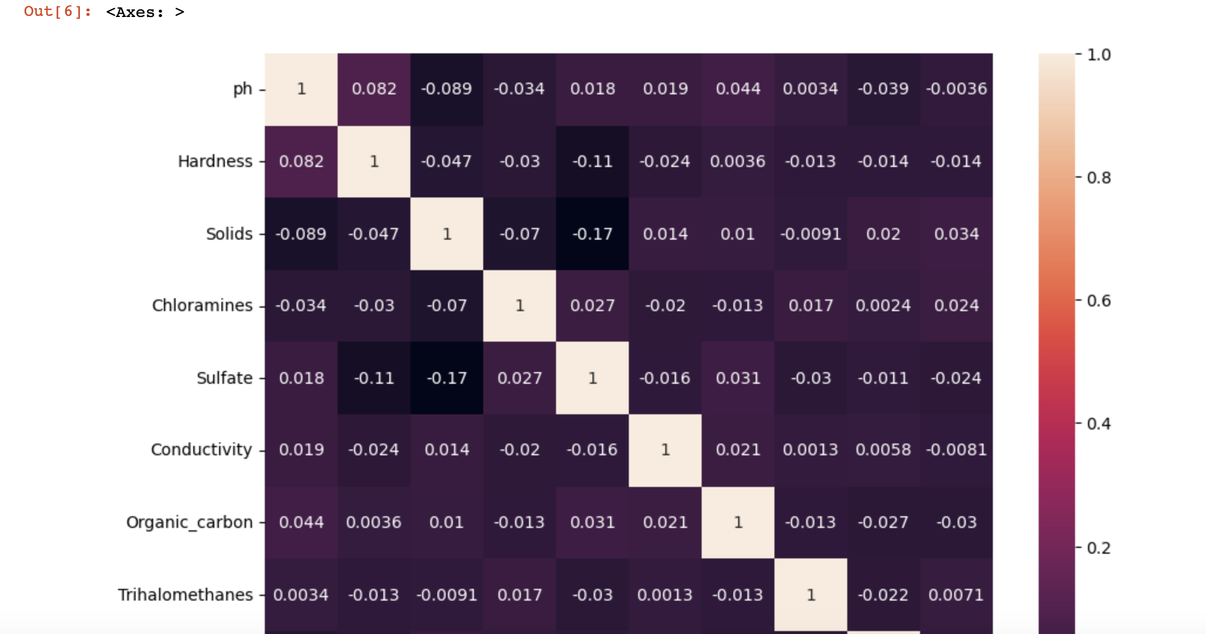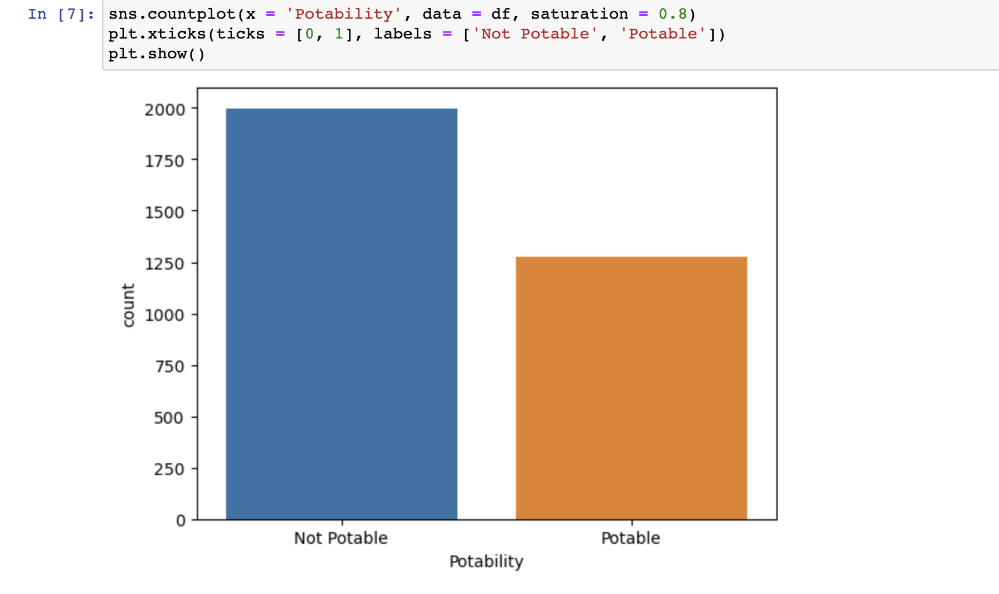nput and output)-**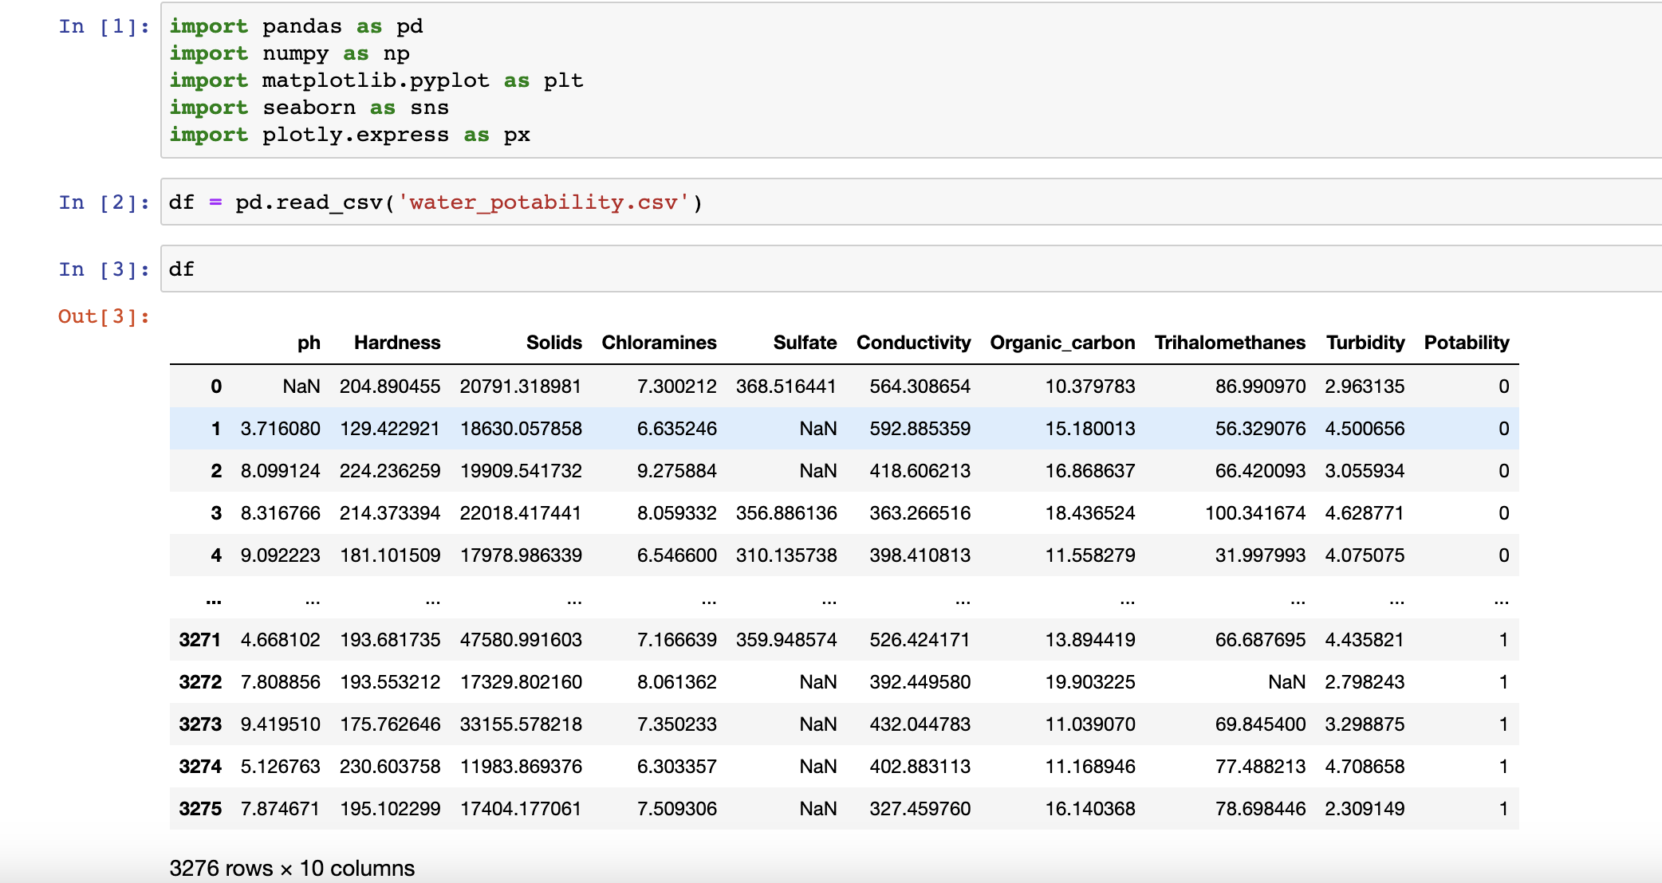

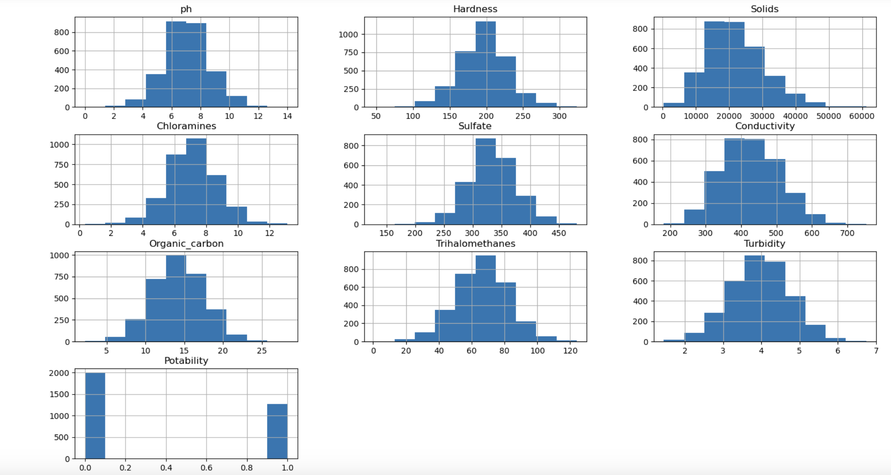

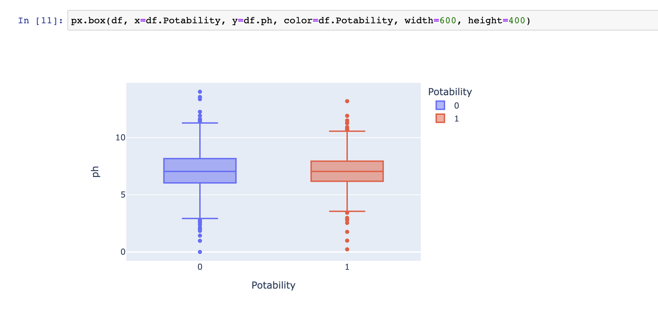

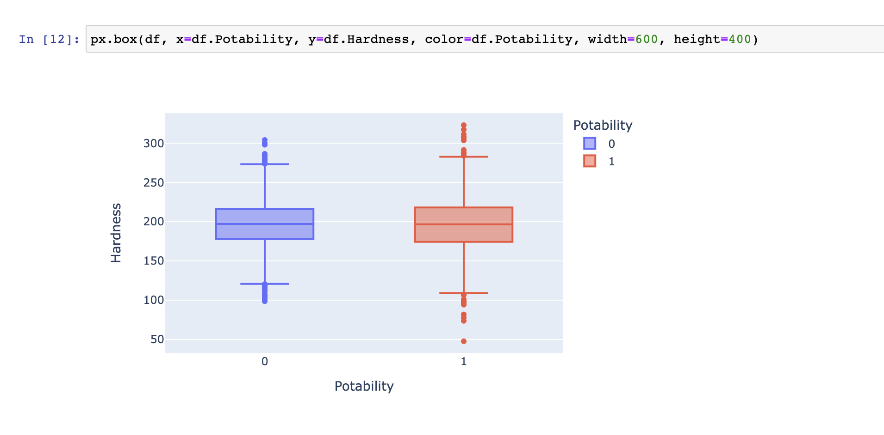

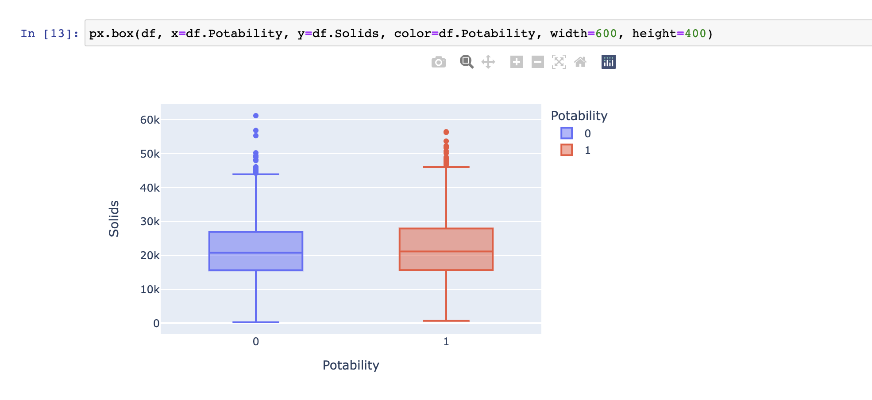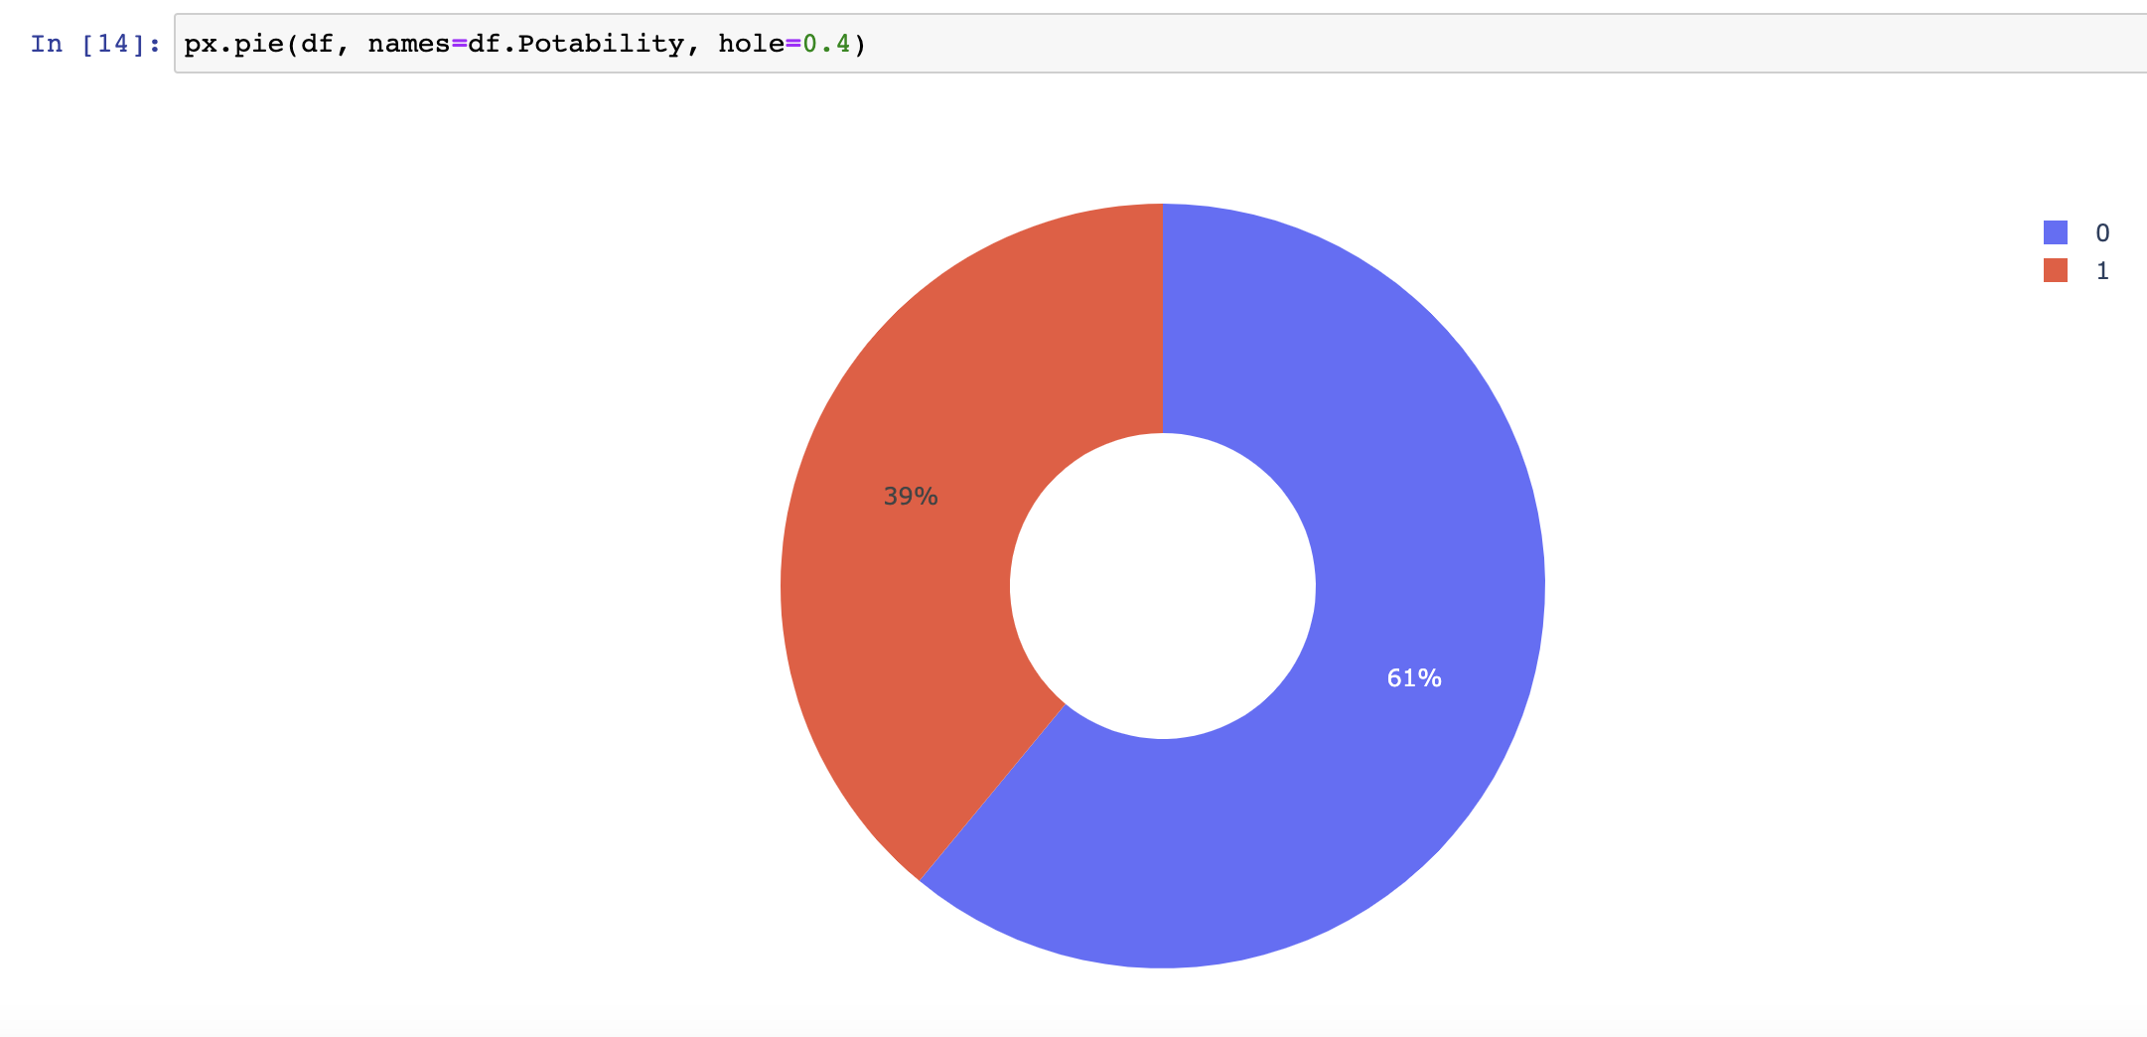



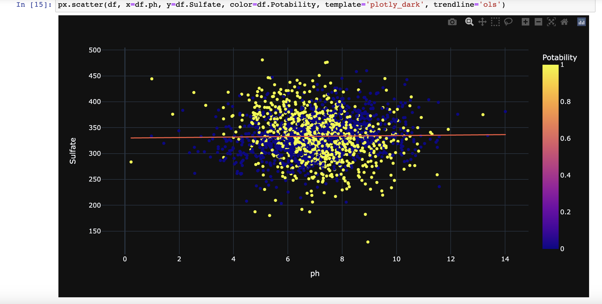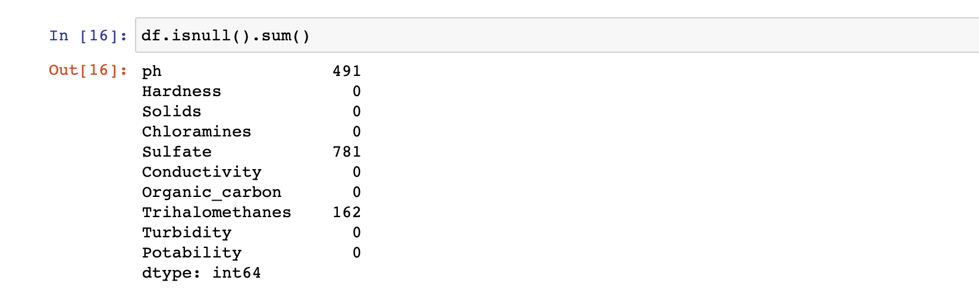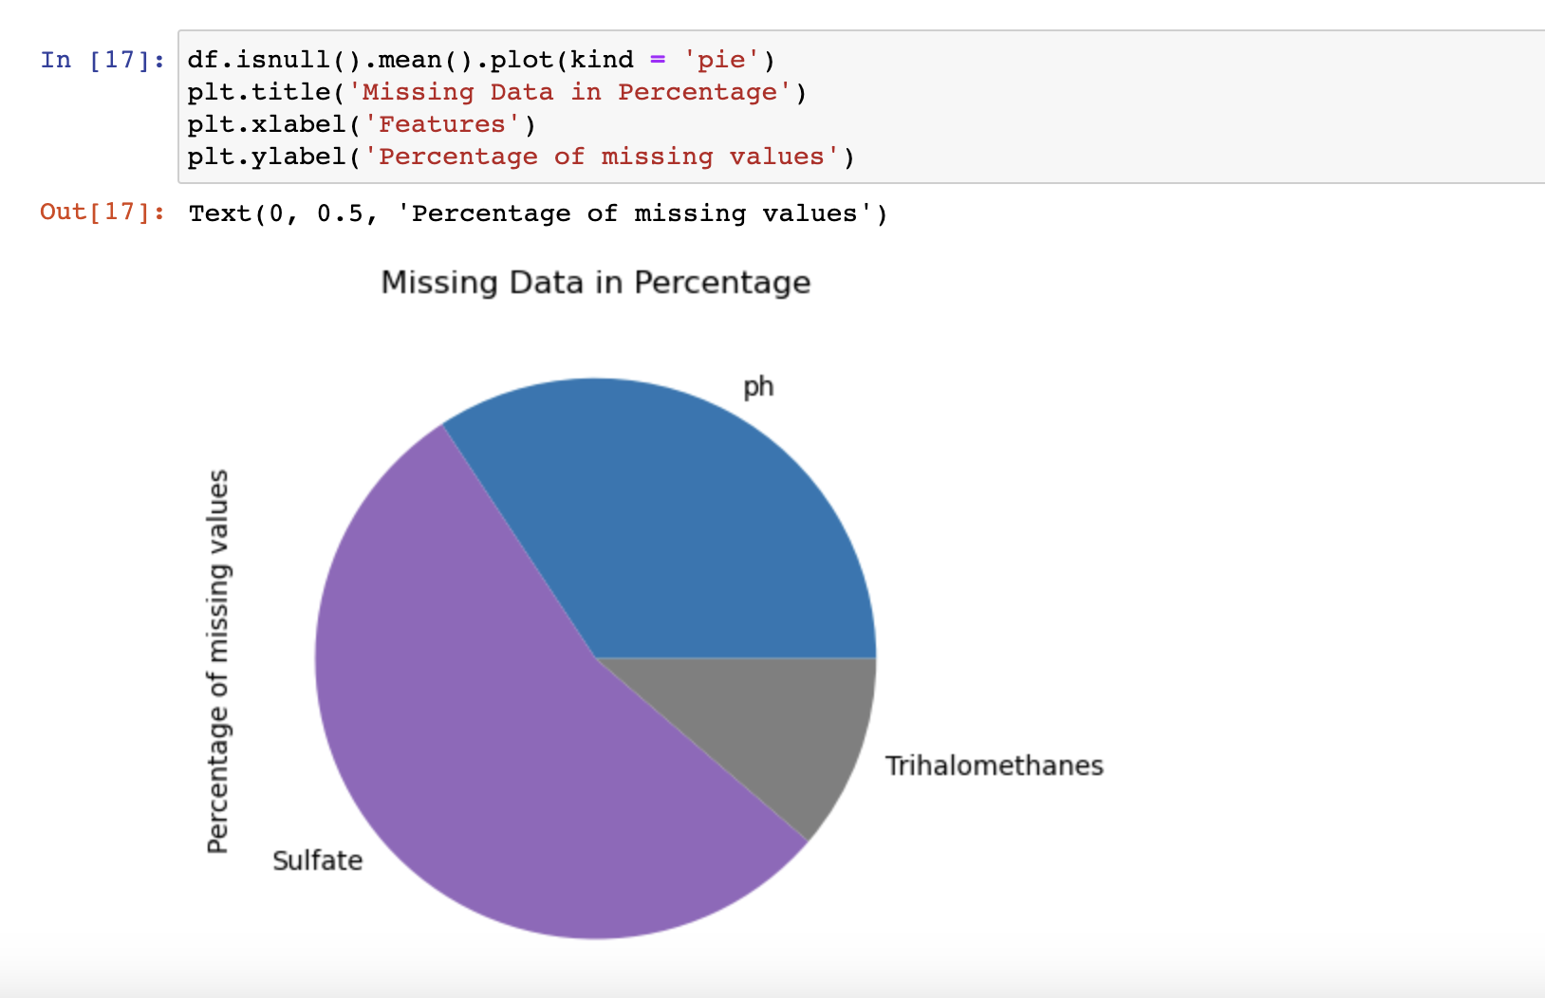

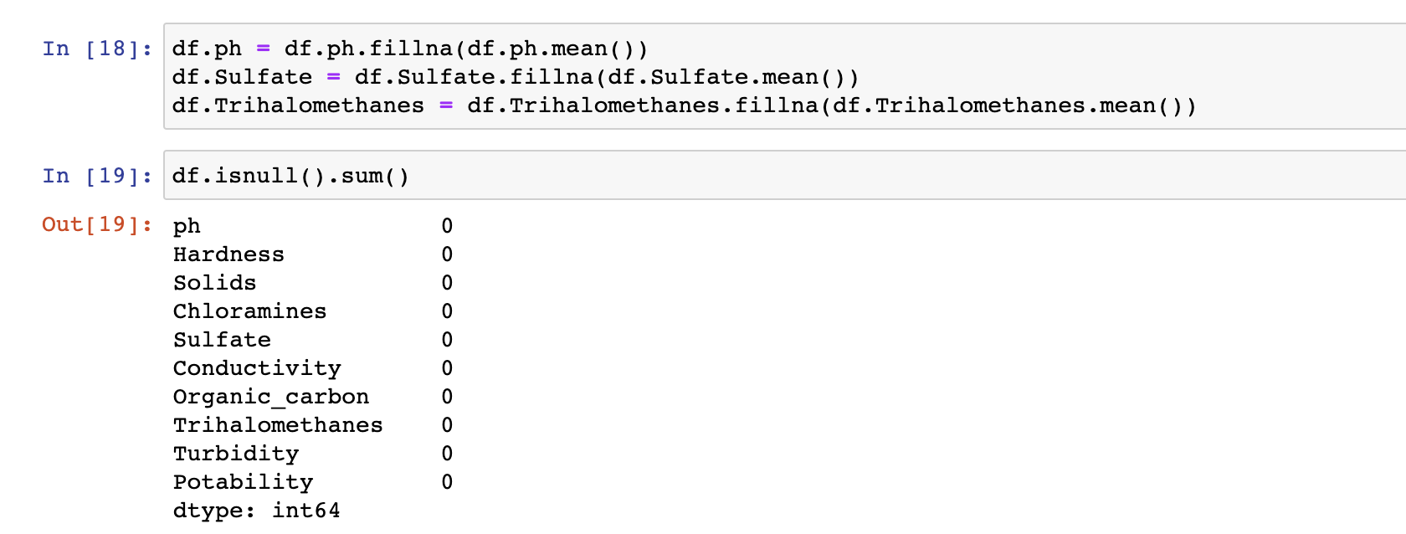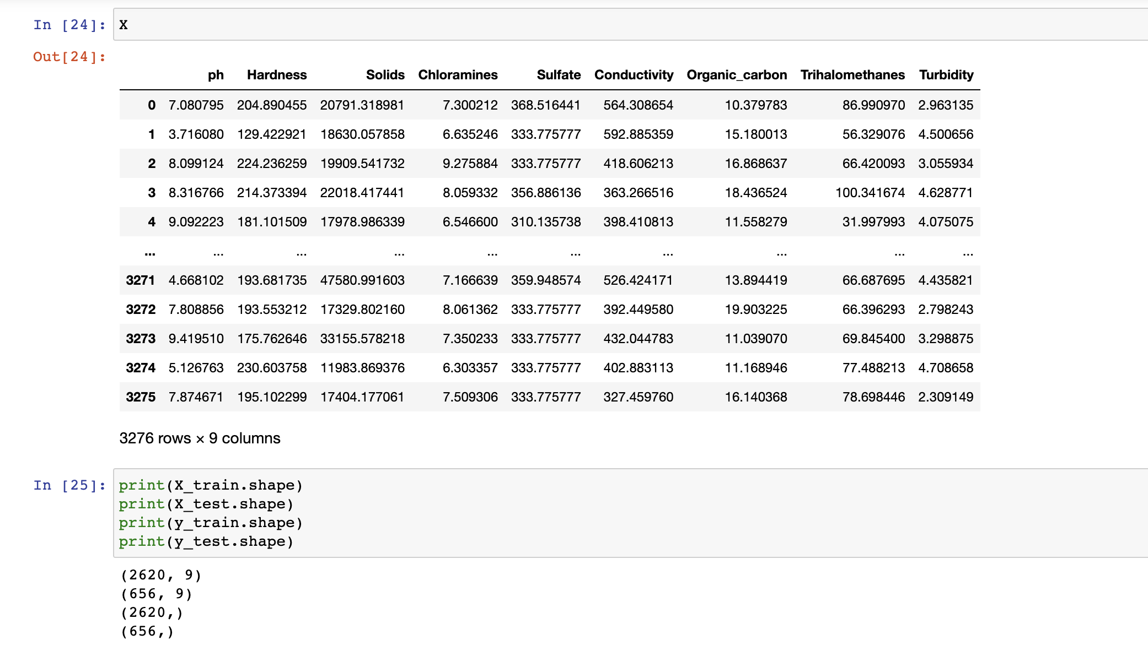

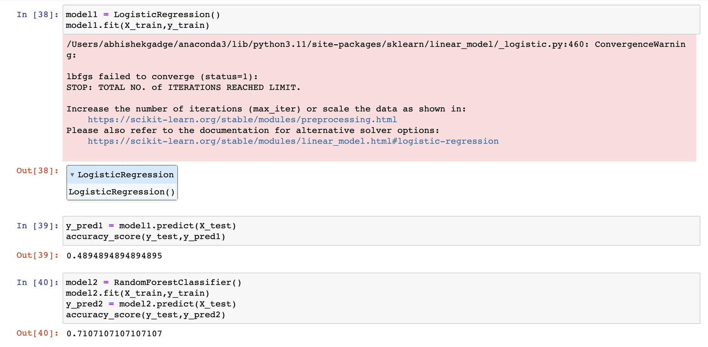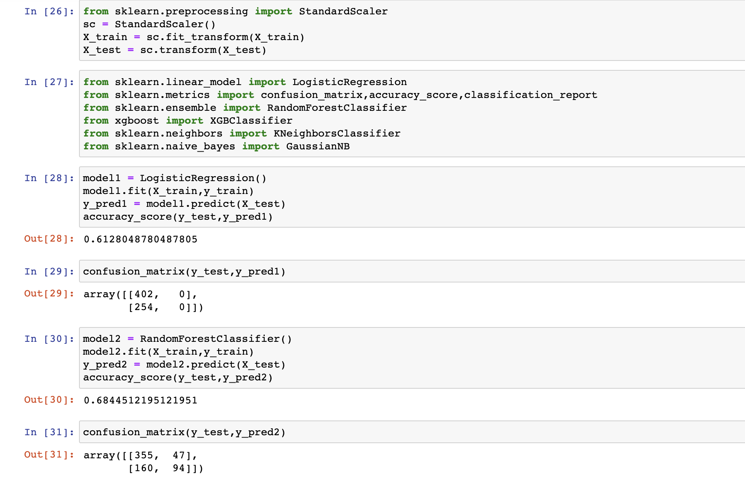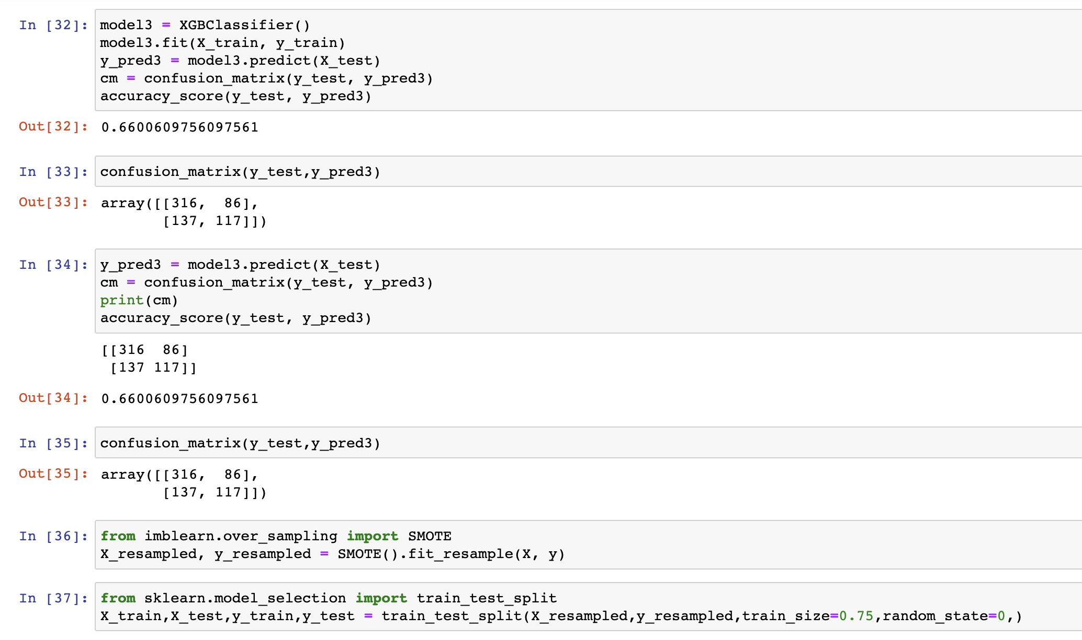

**CHAPTER-12**

**water quality prediction file**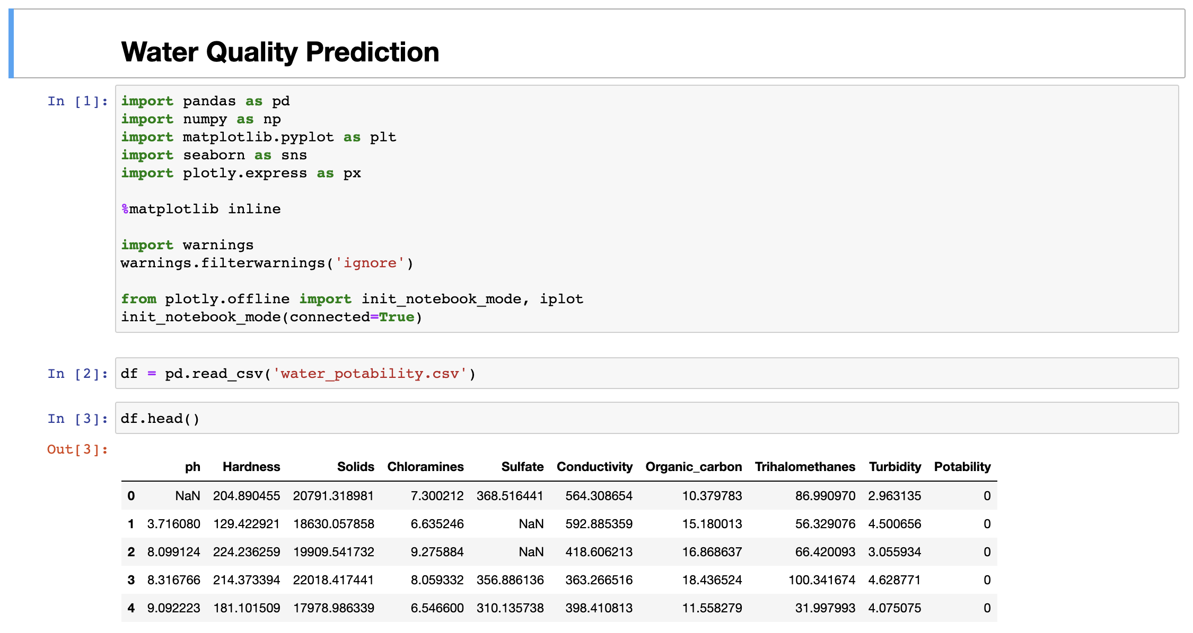

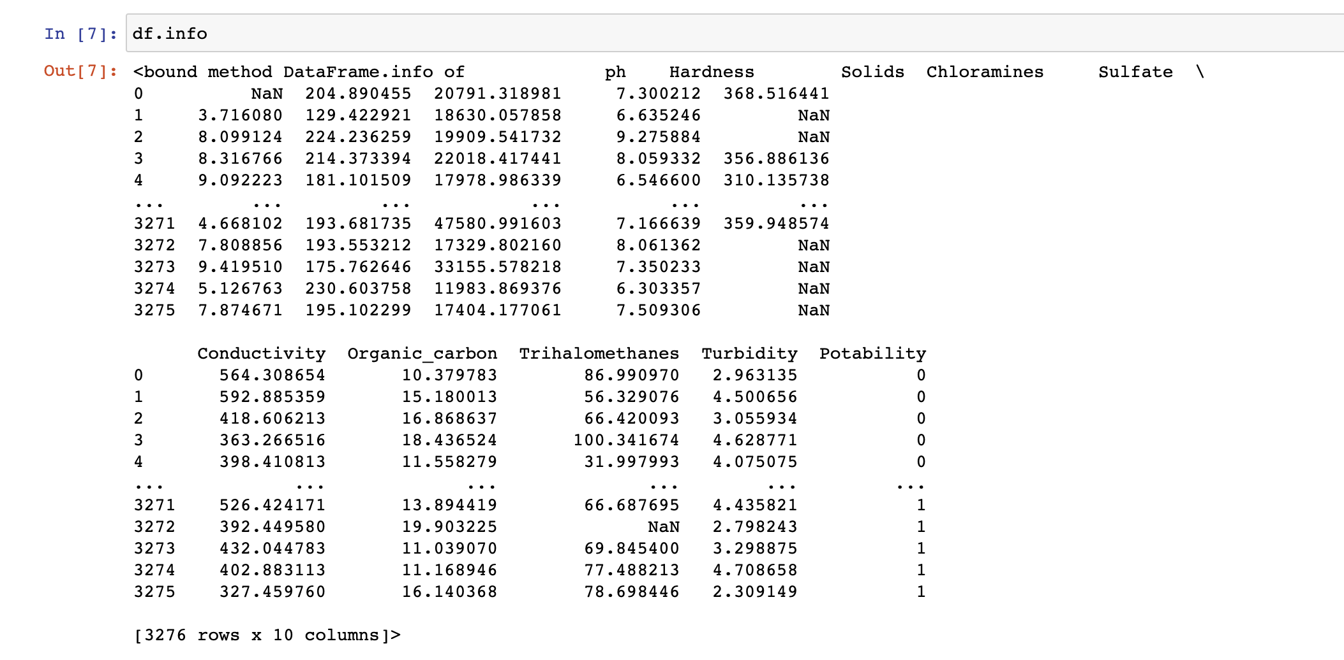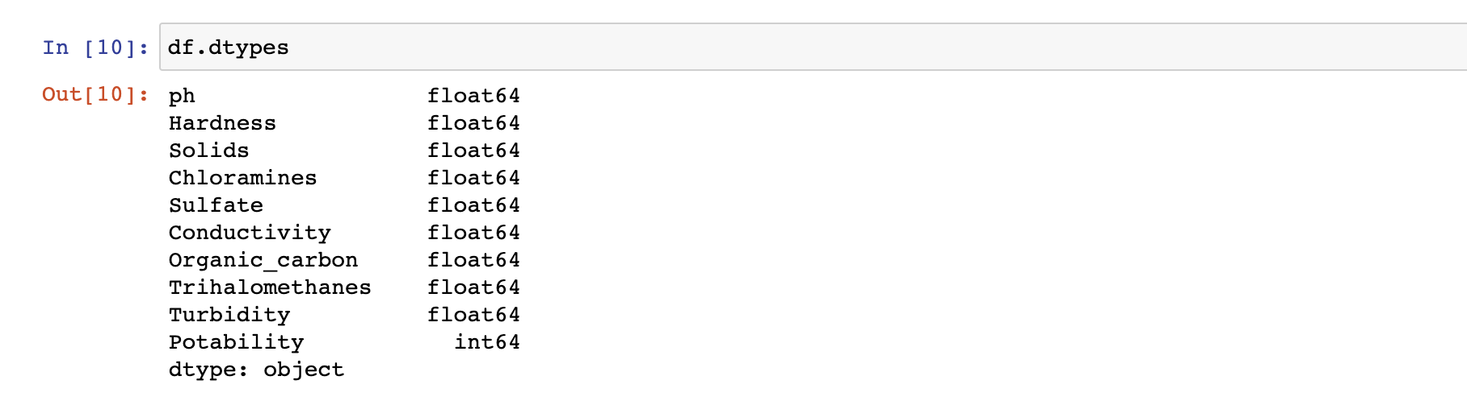

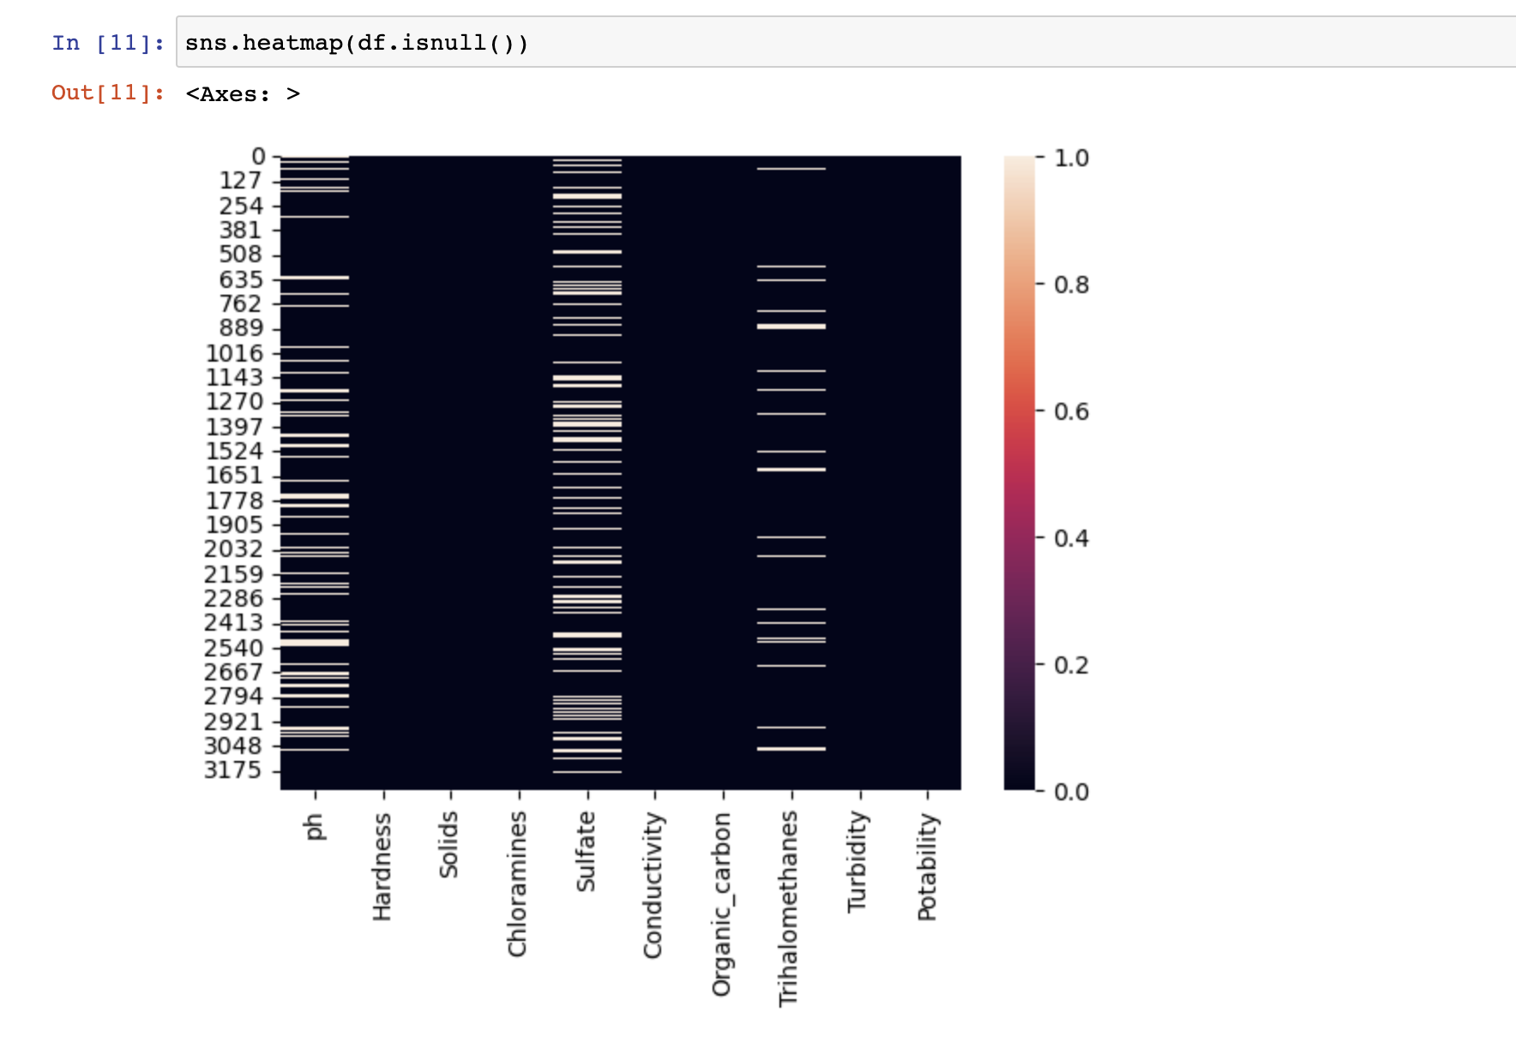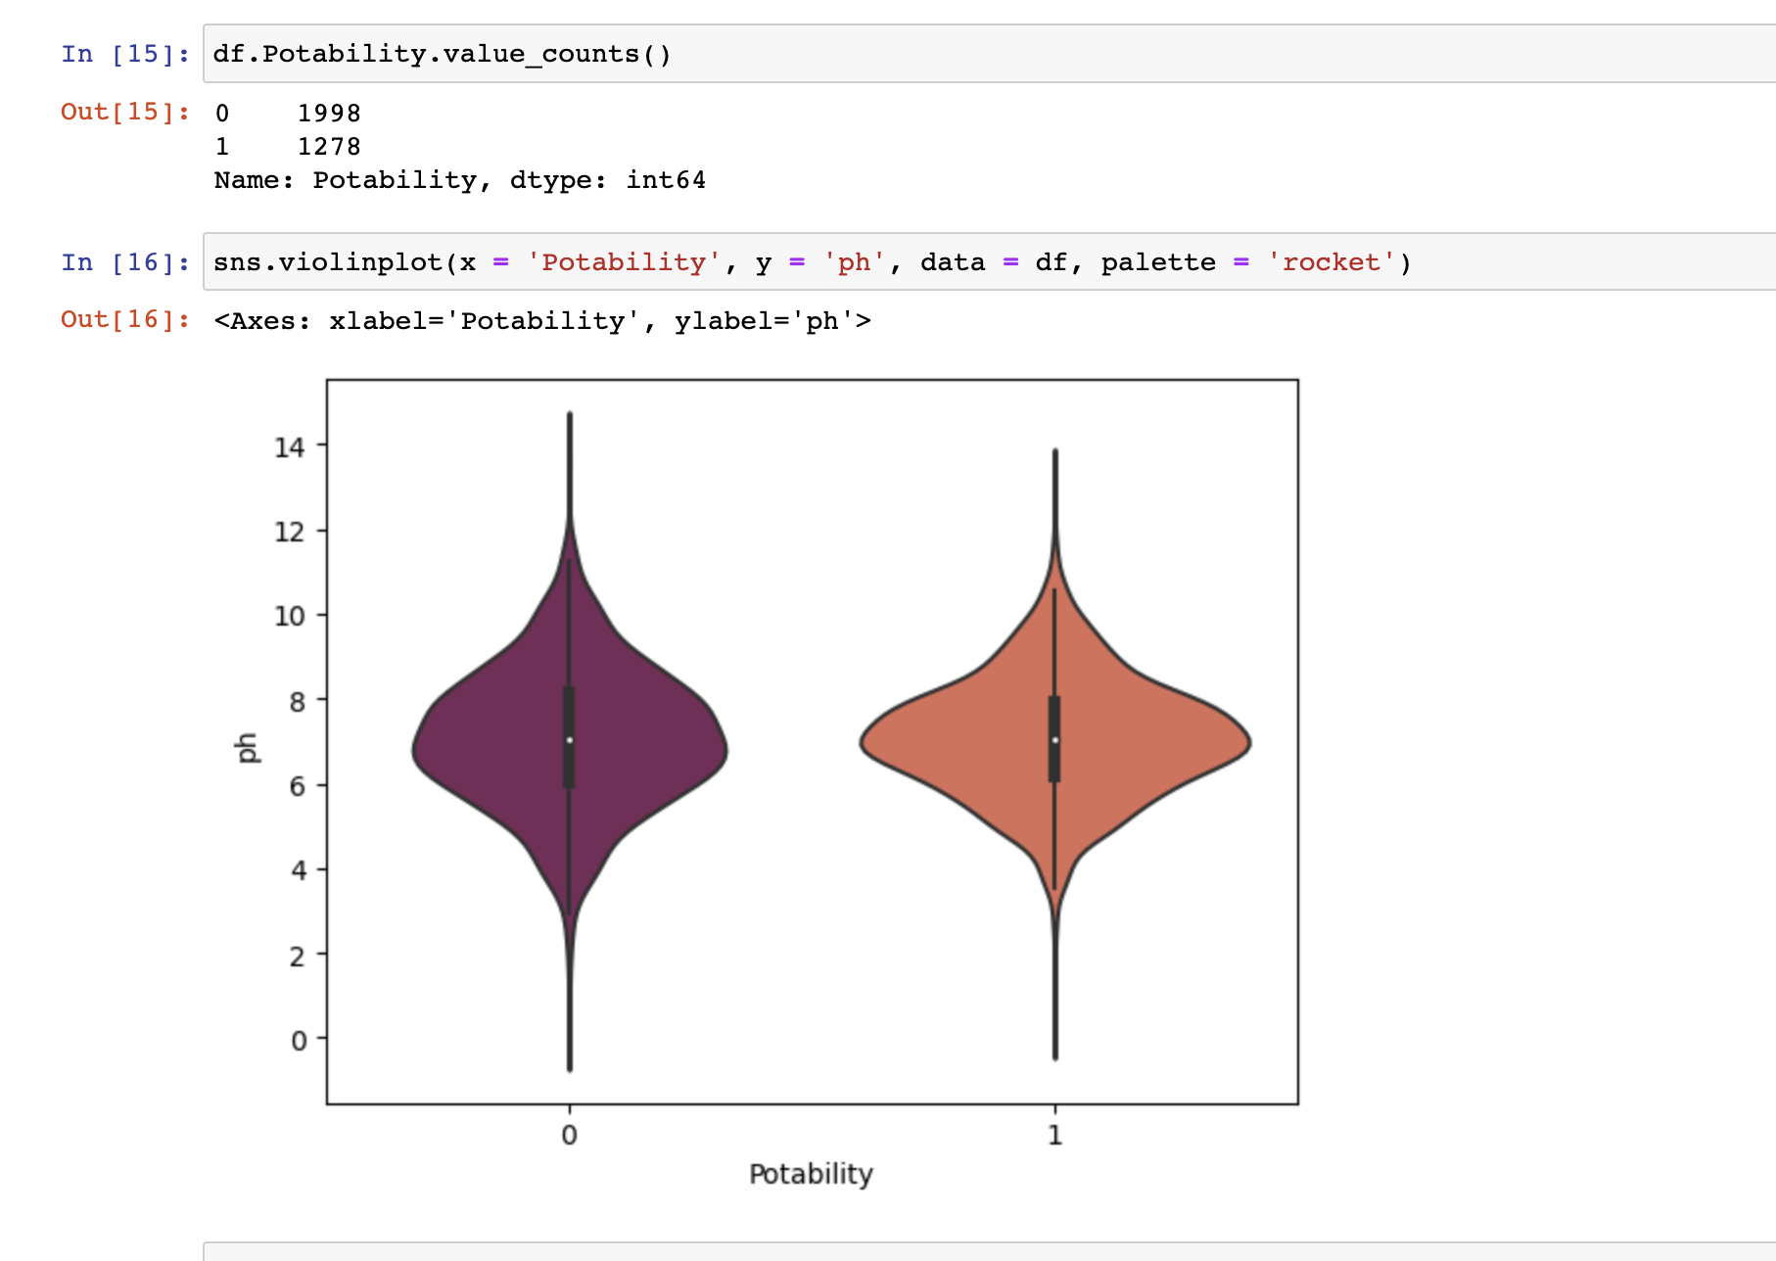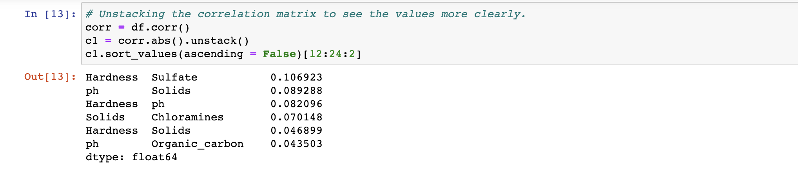

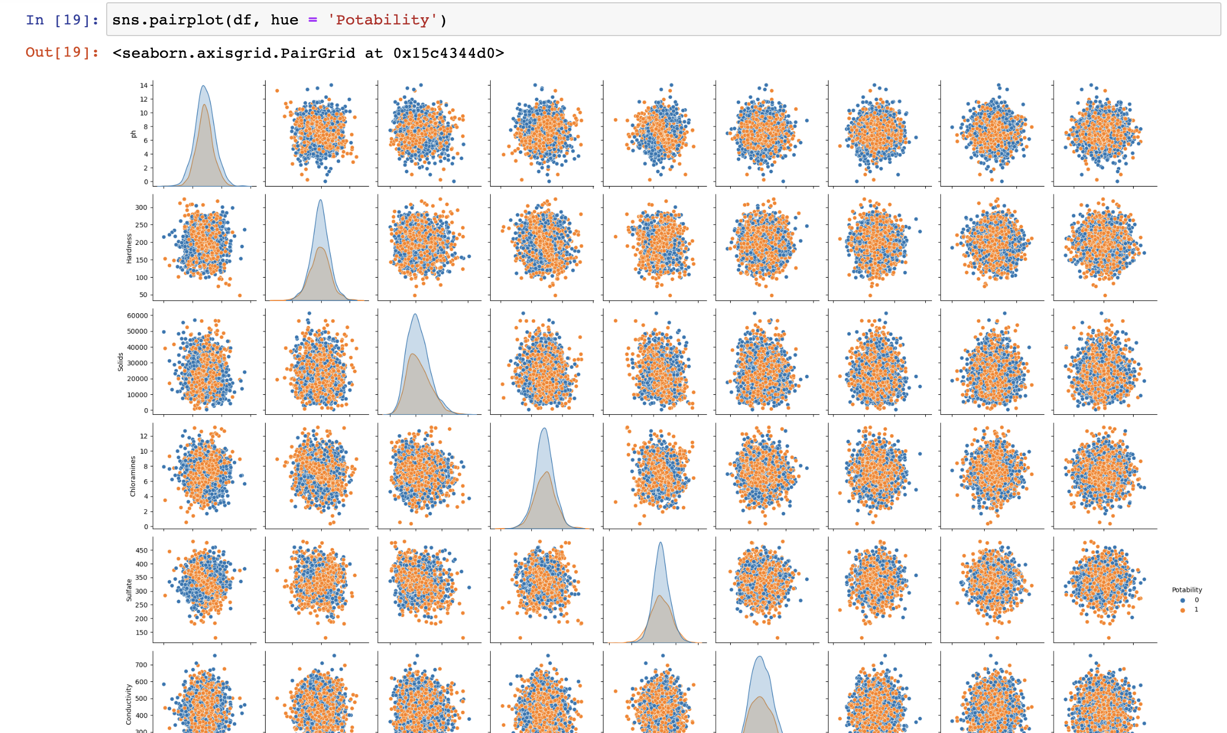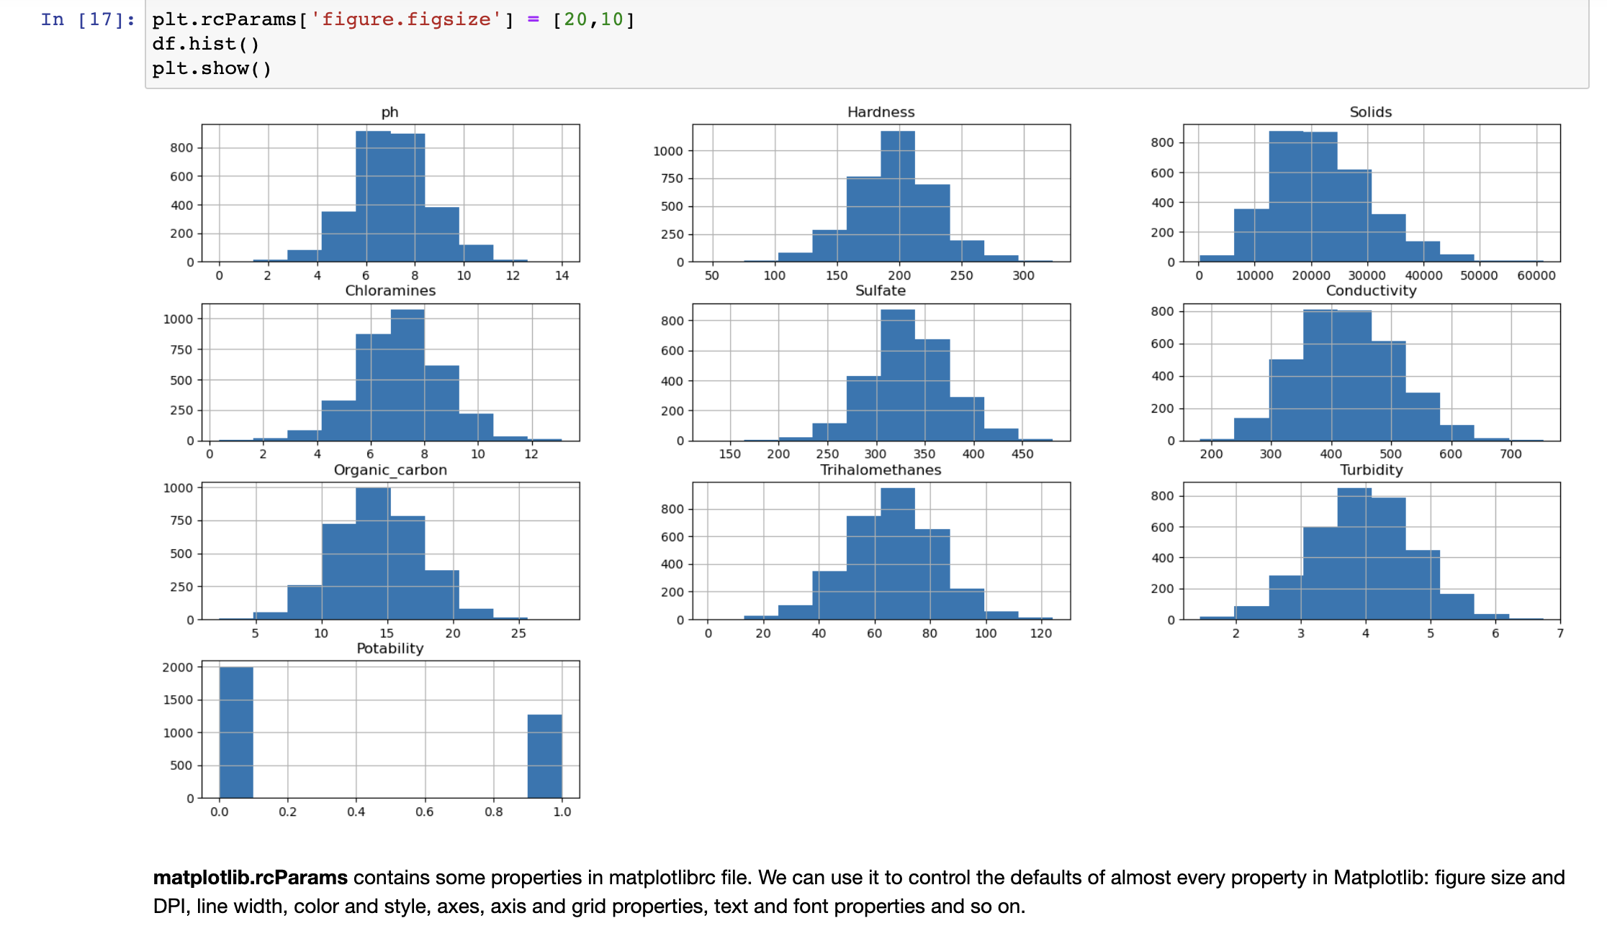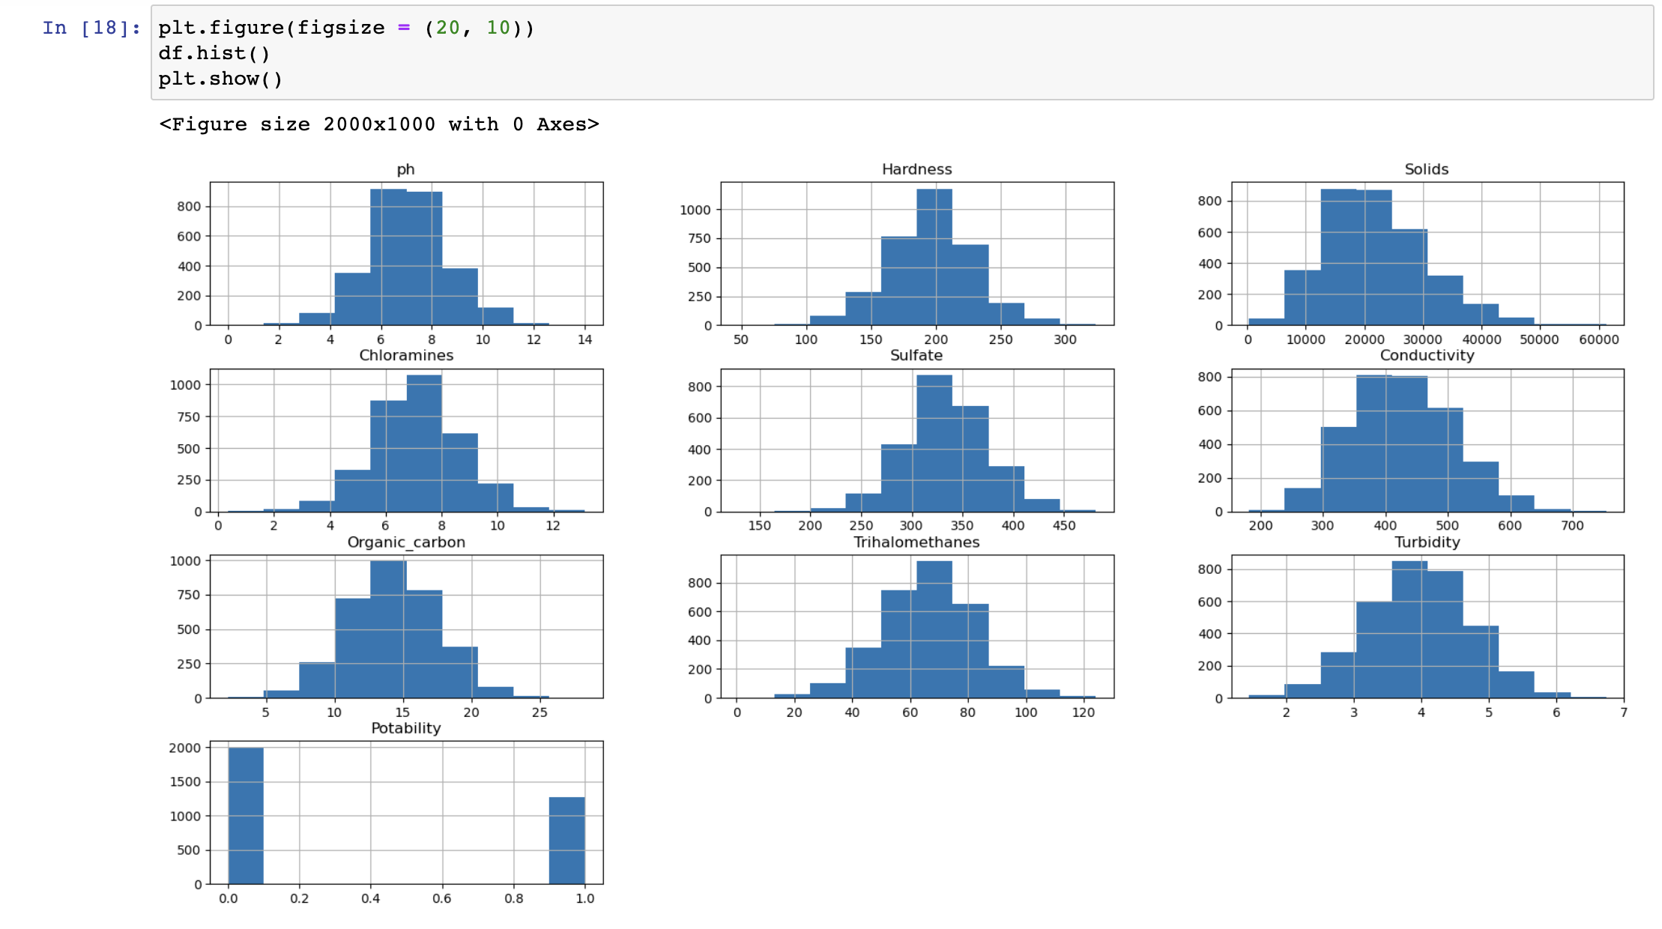

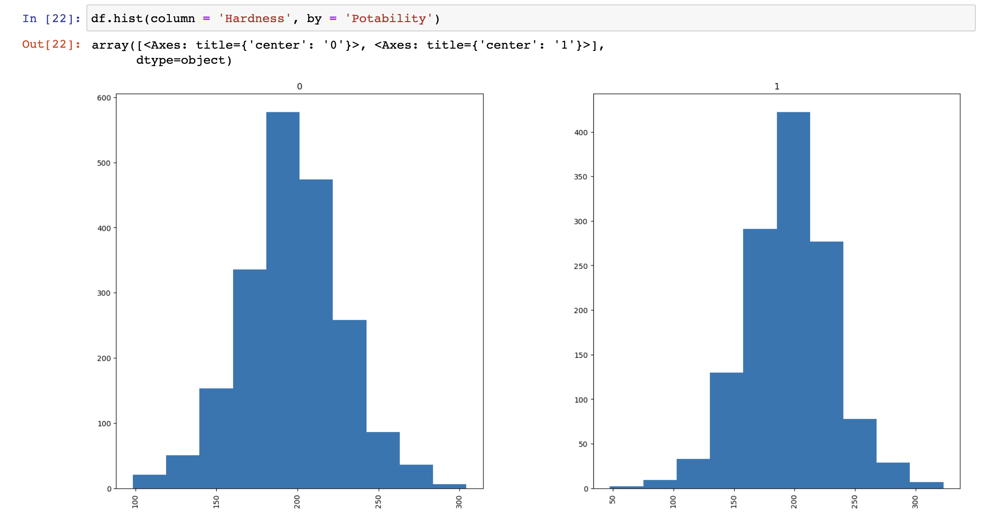

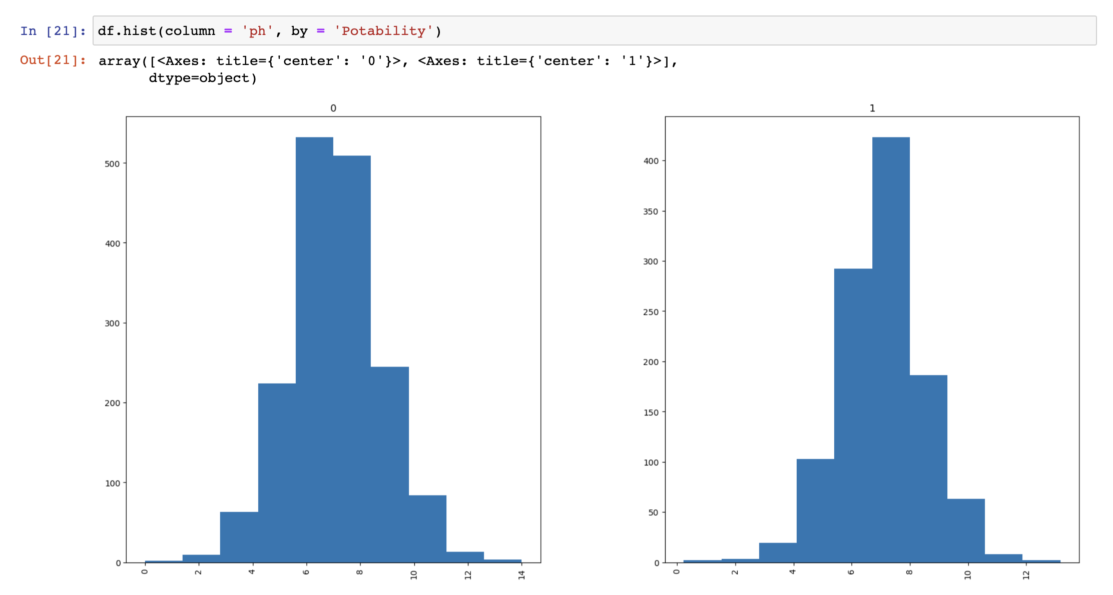

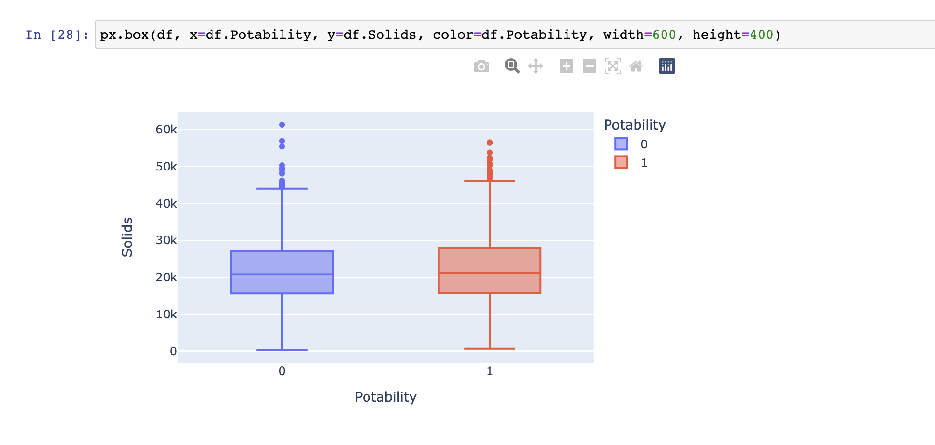

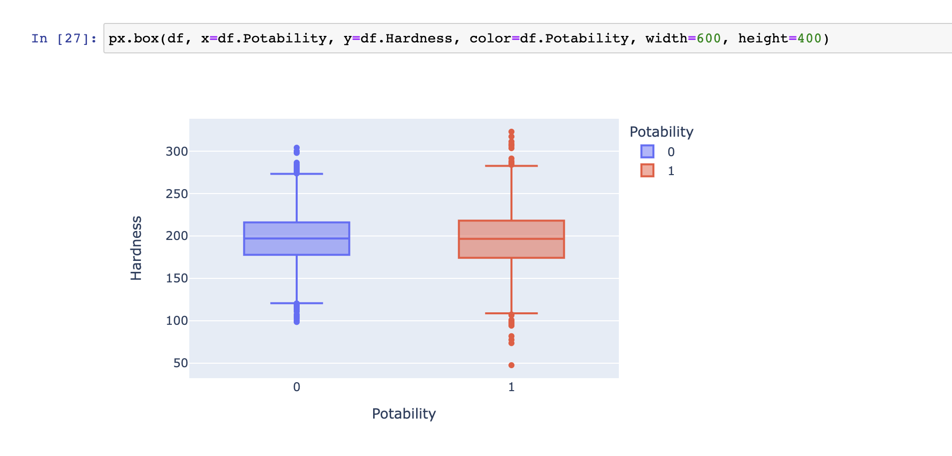

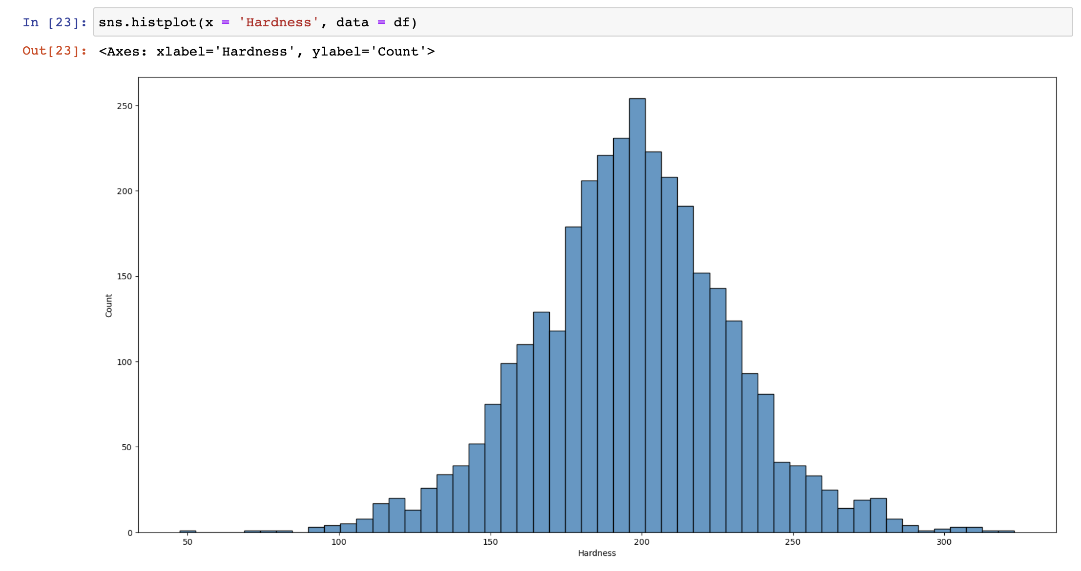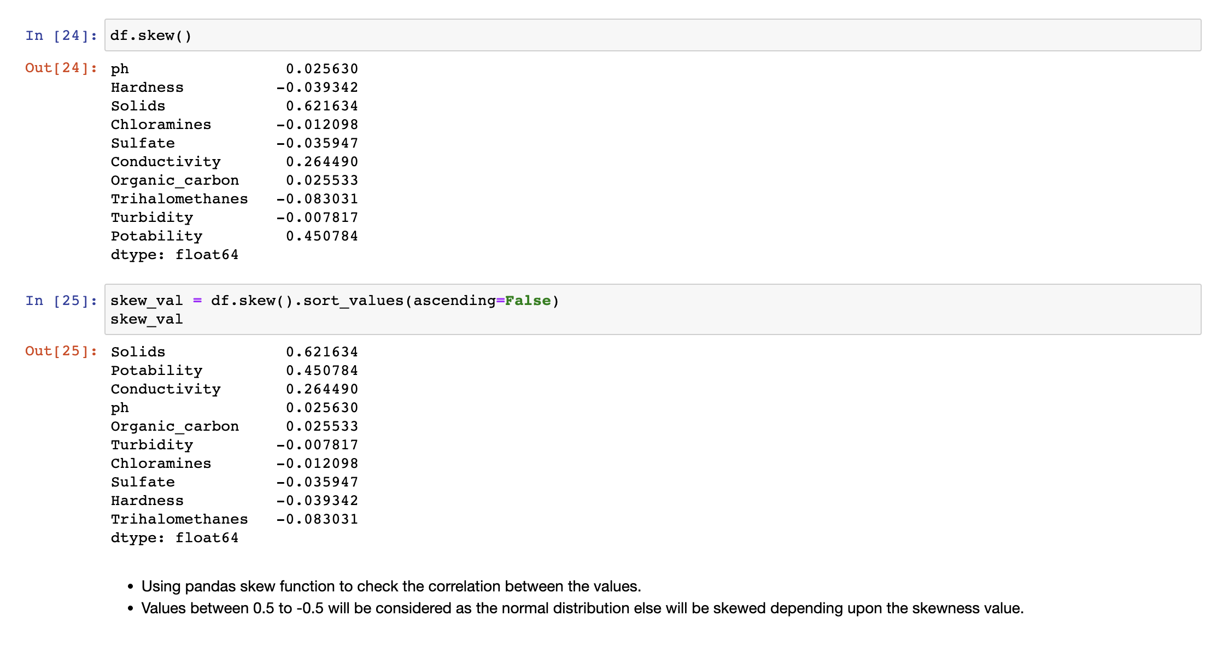

.

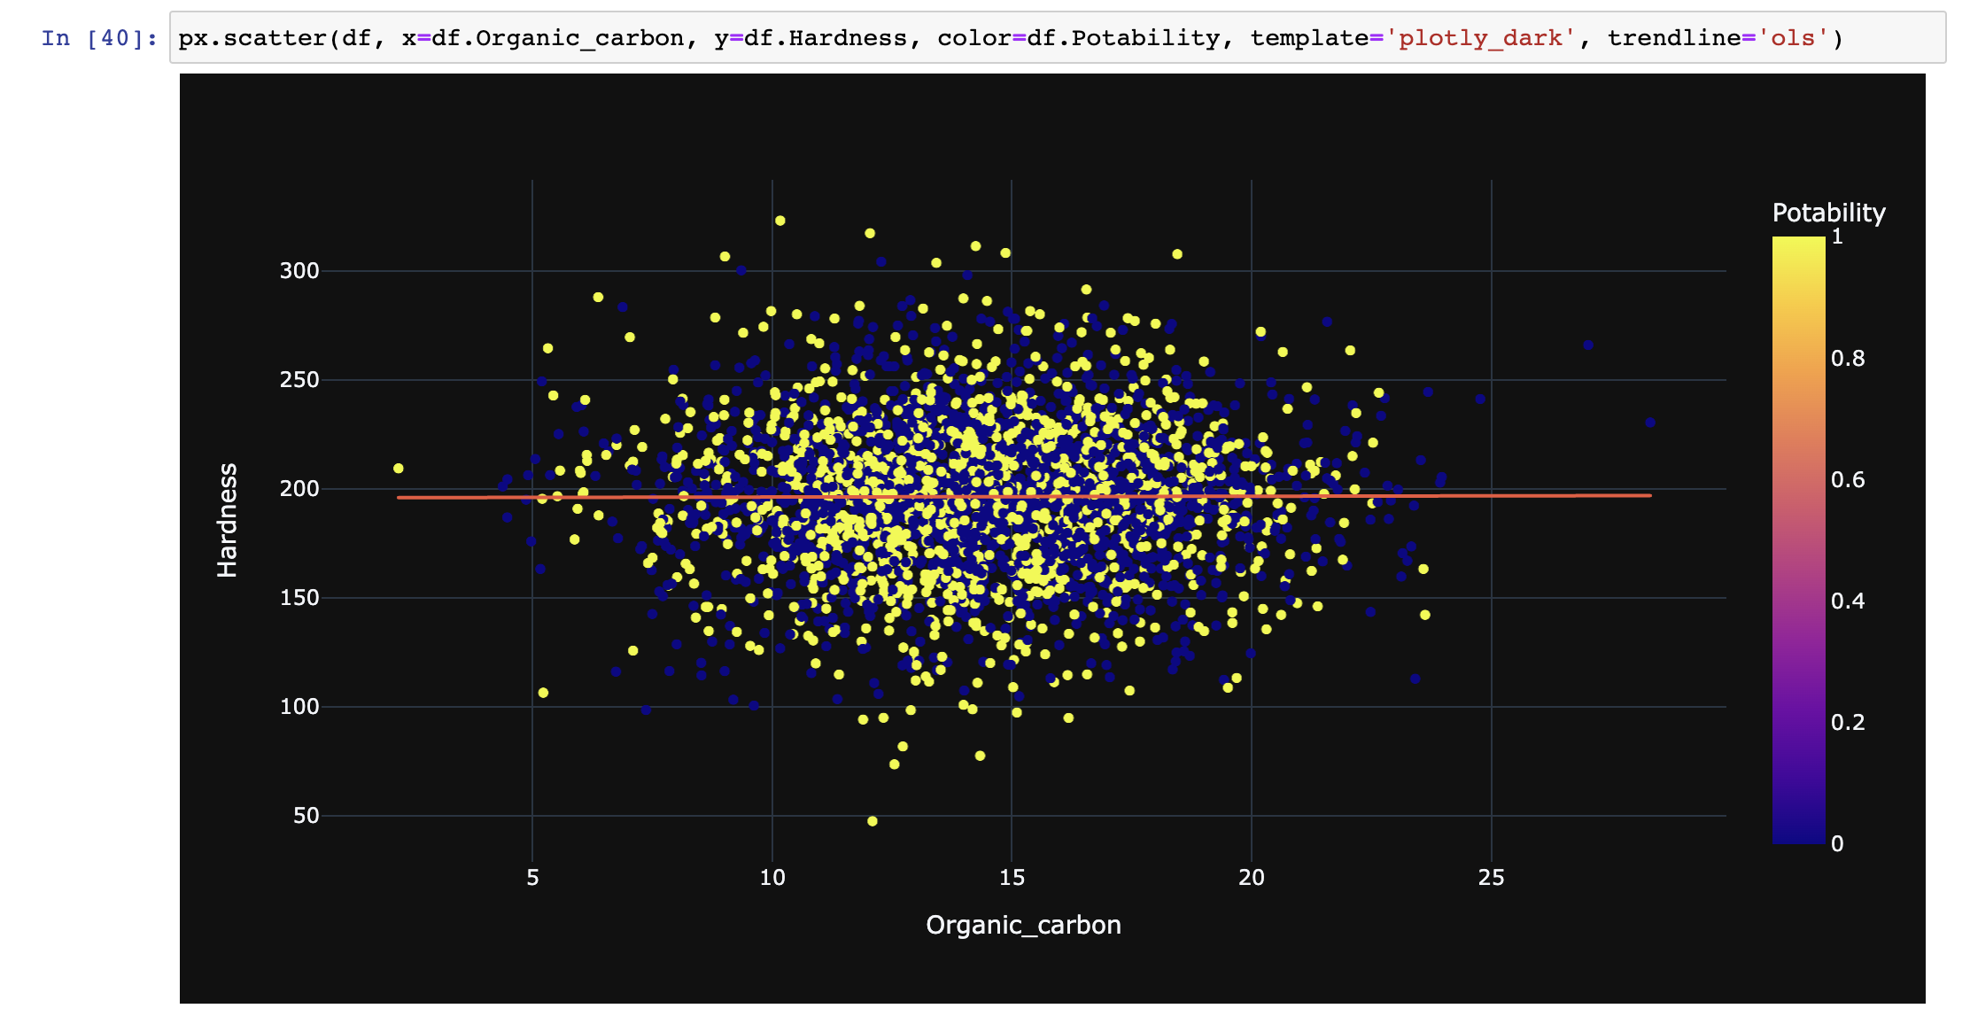

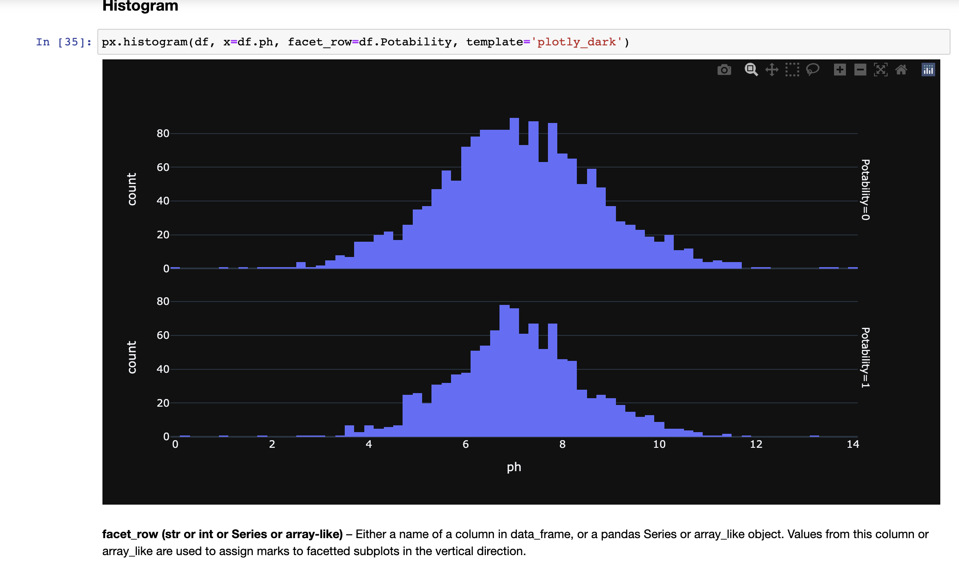

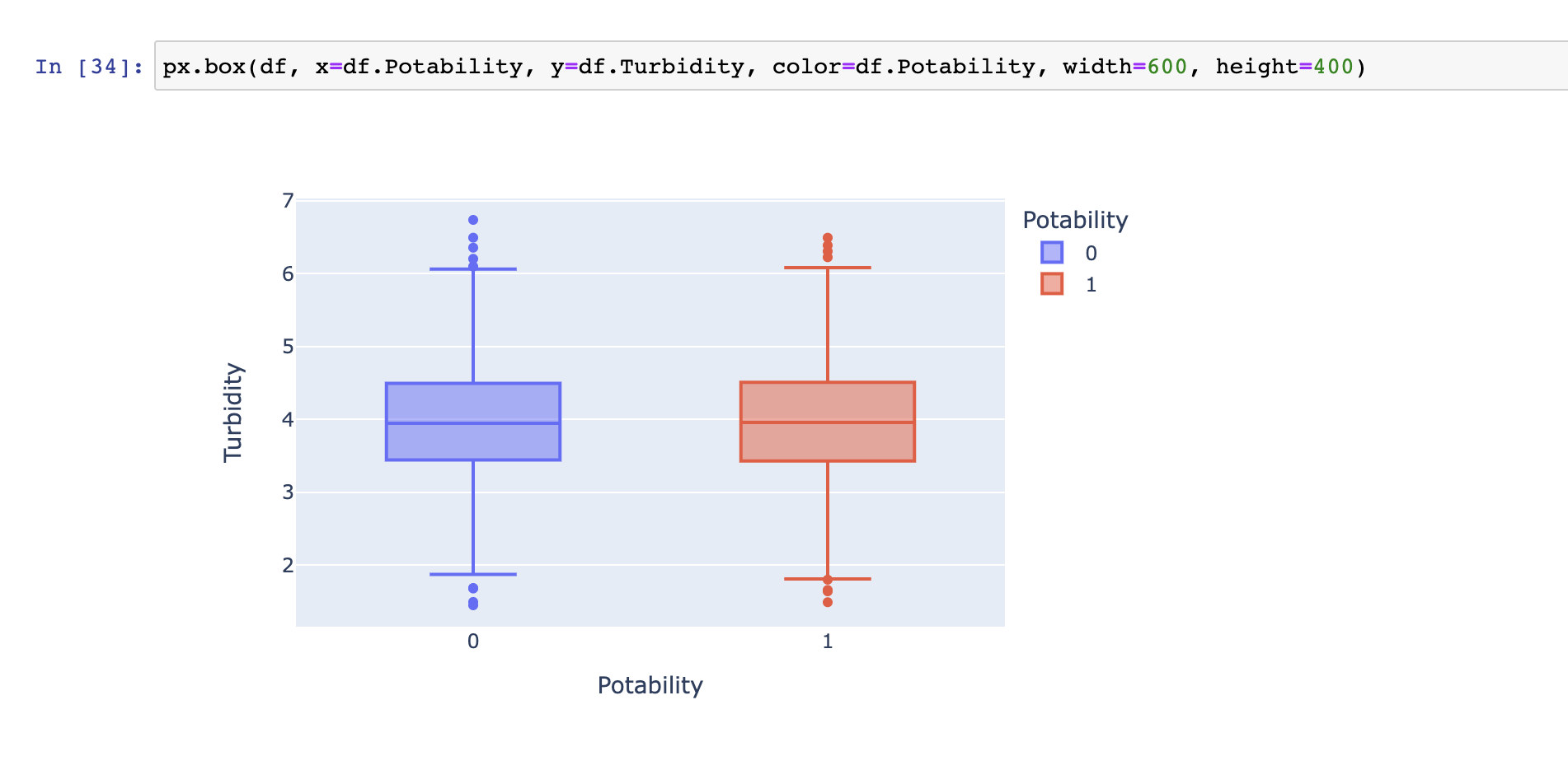

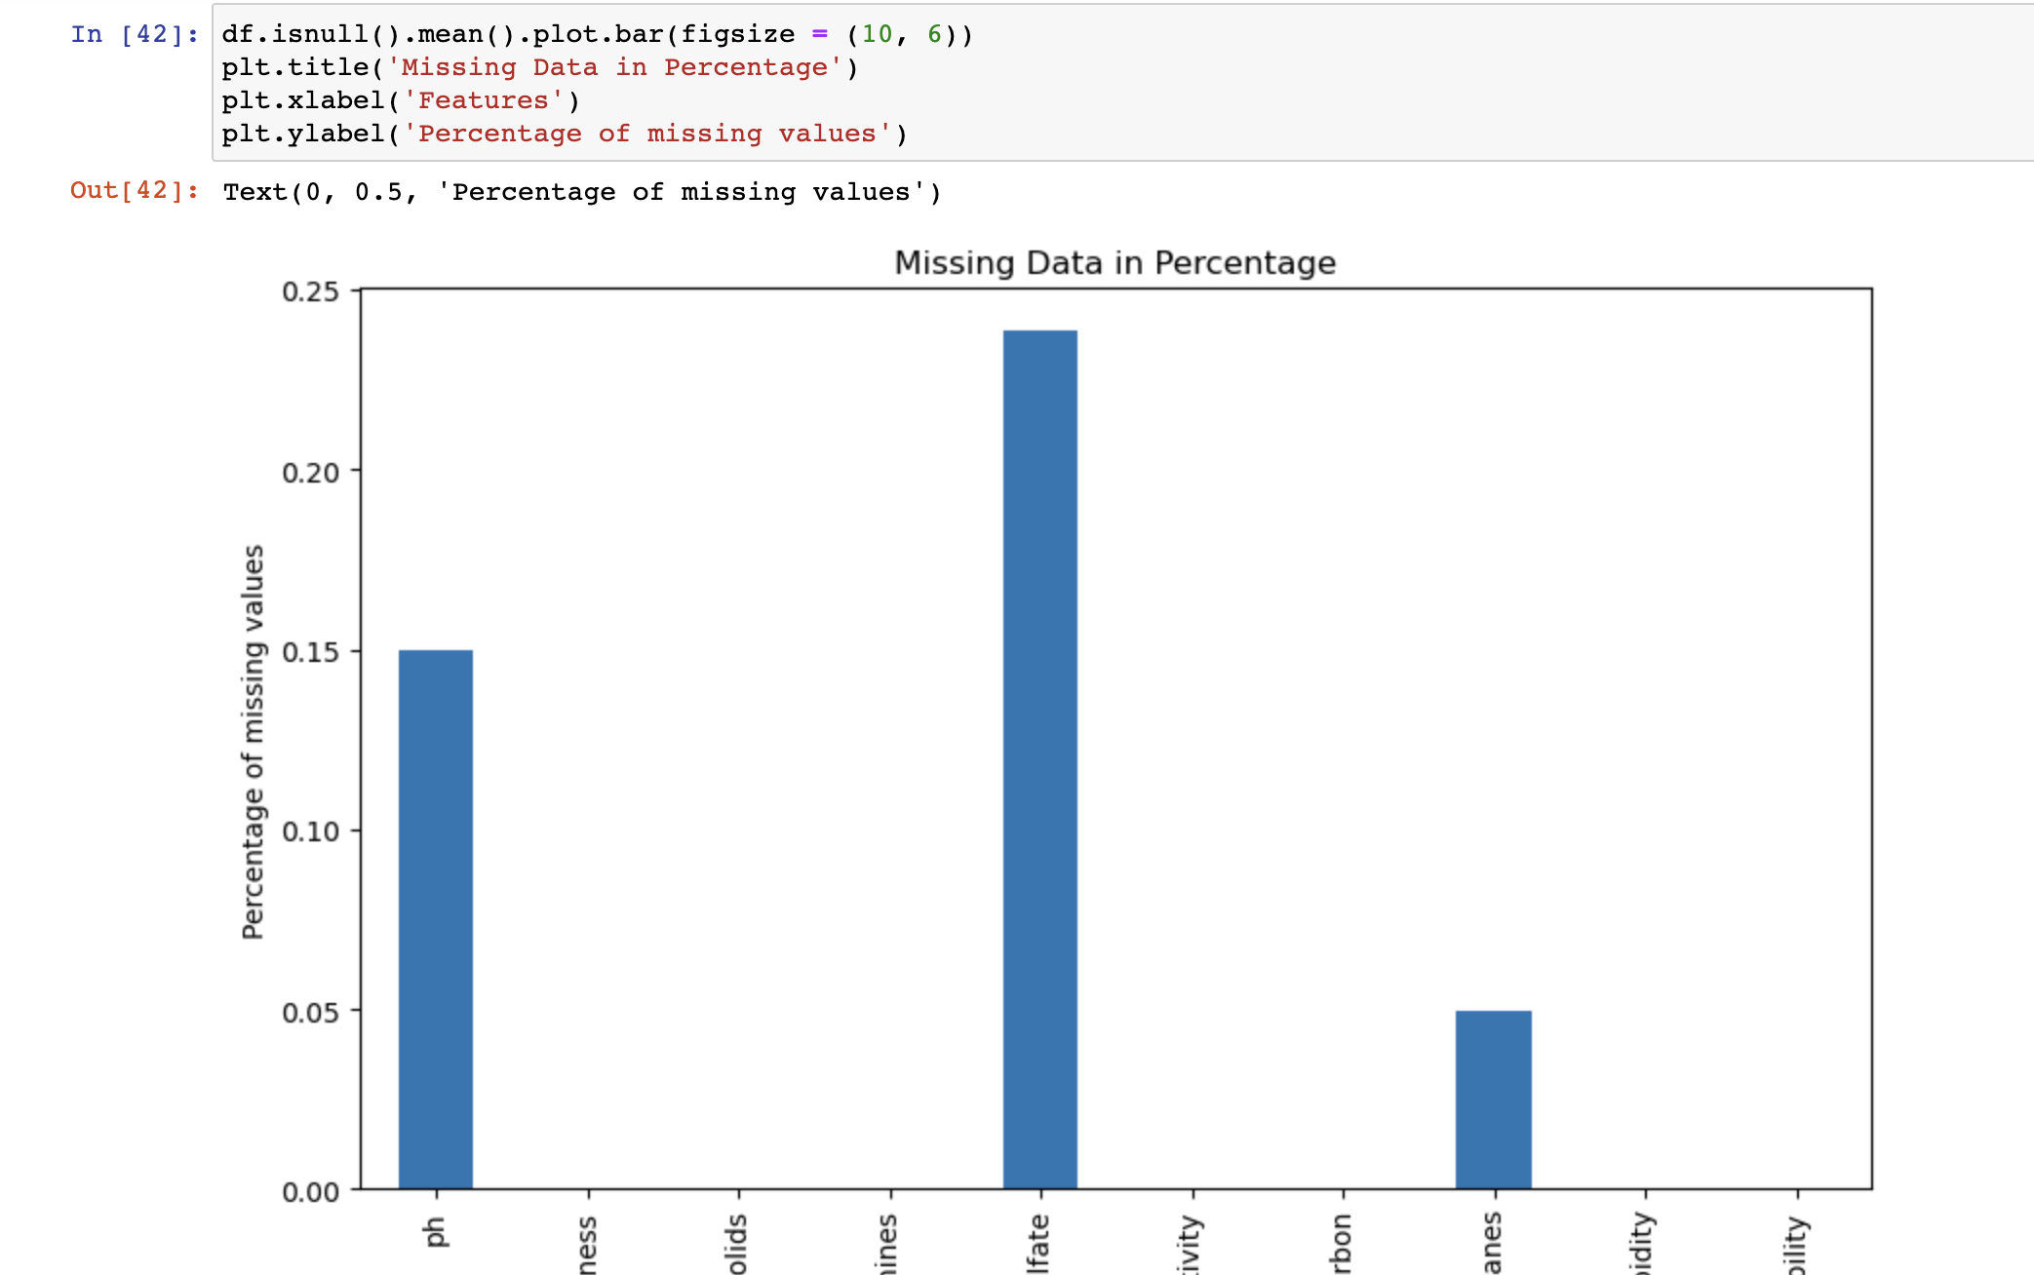

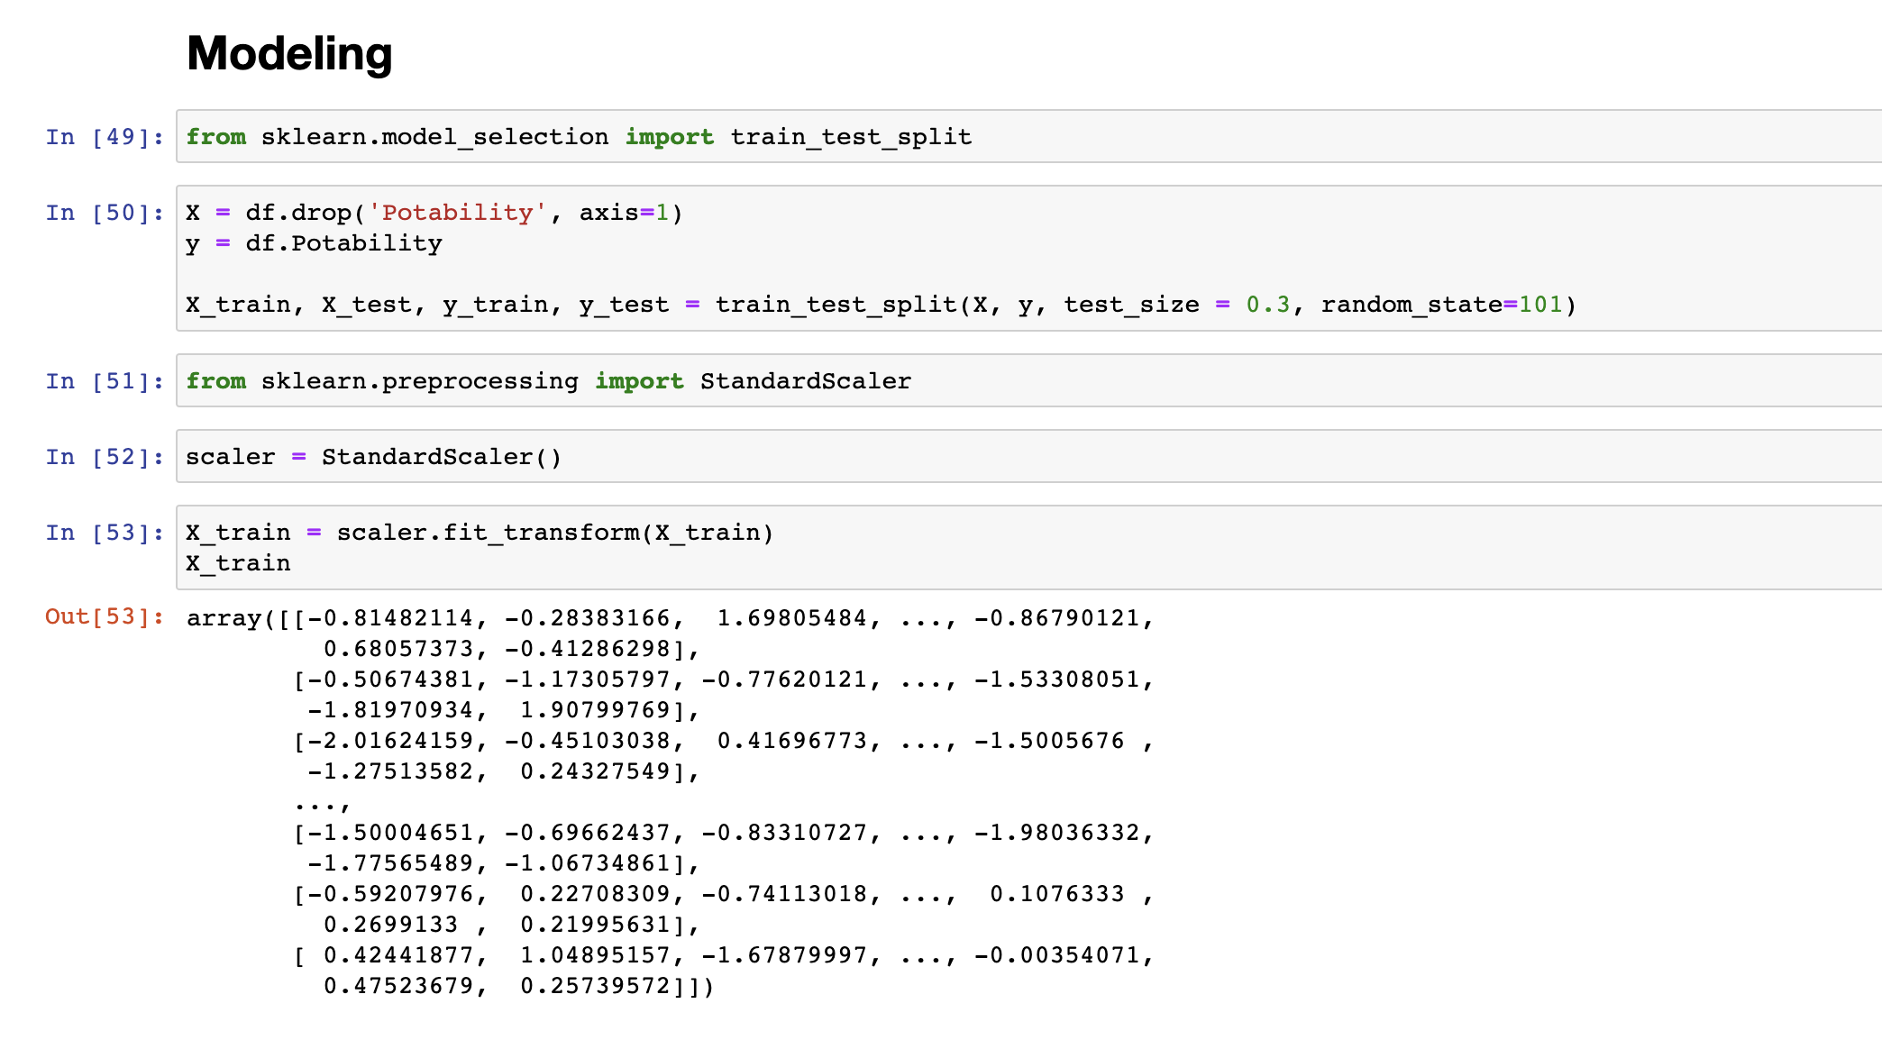

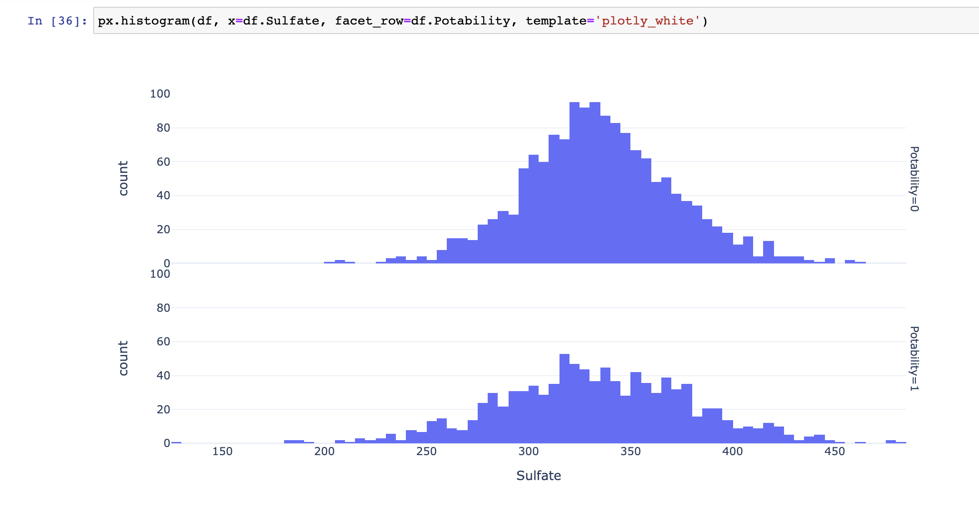

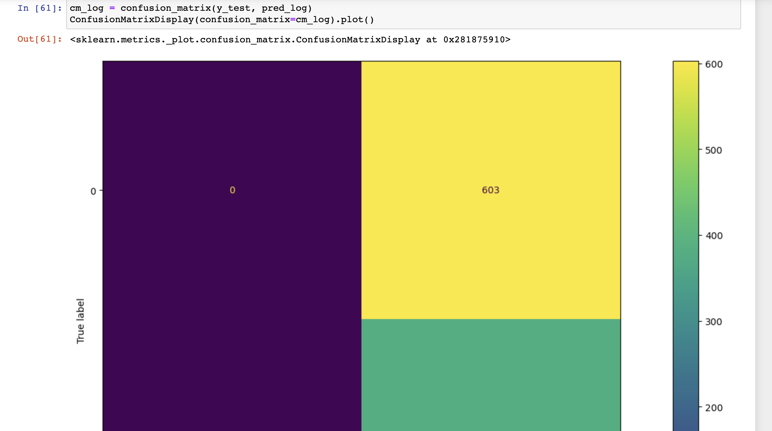

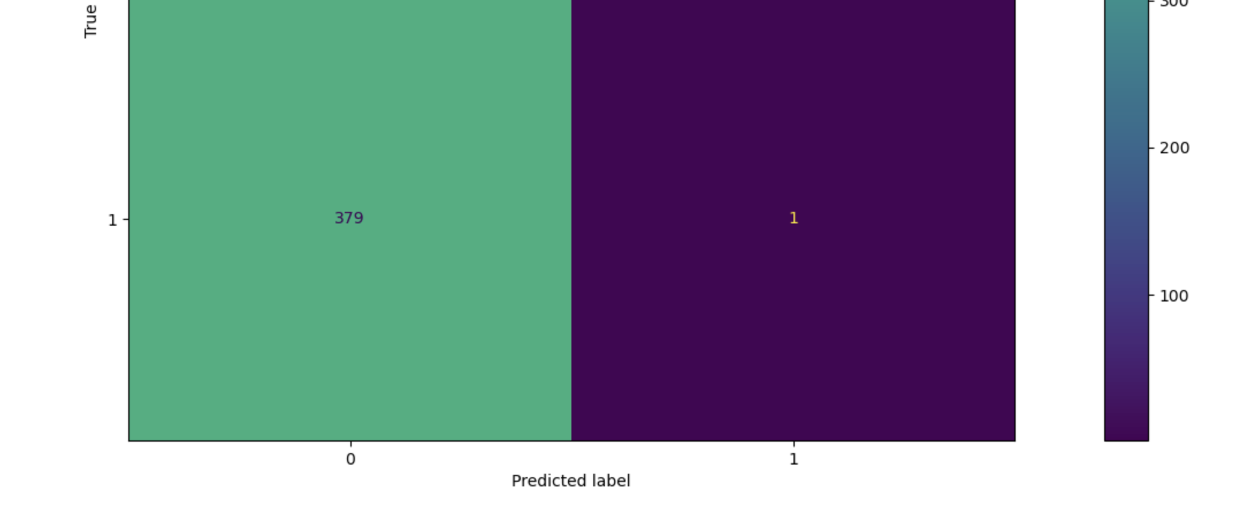

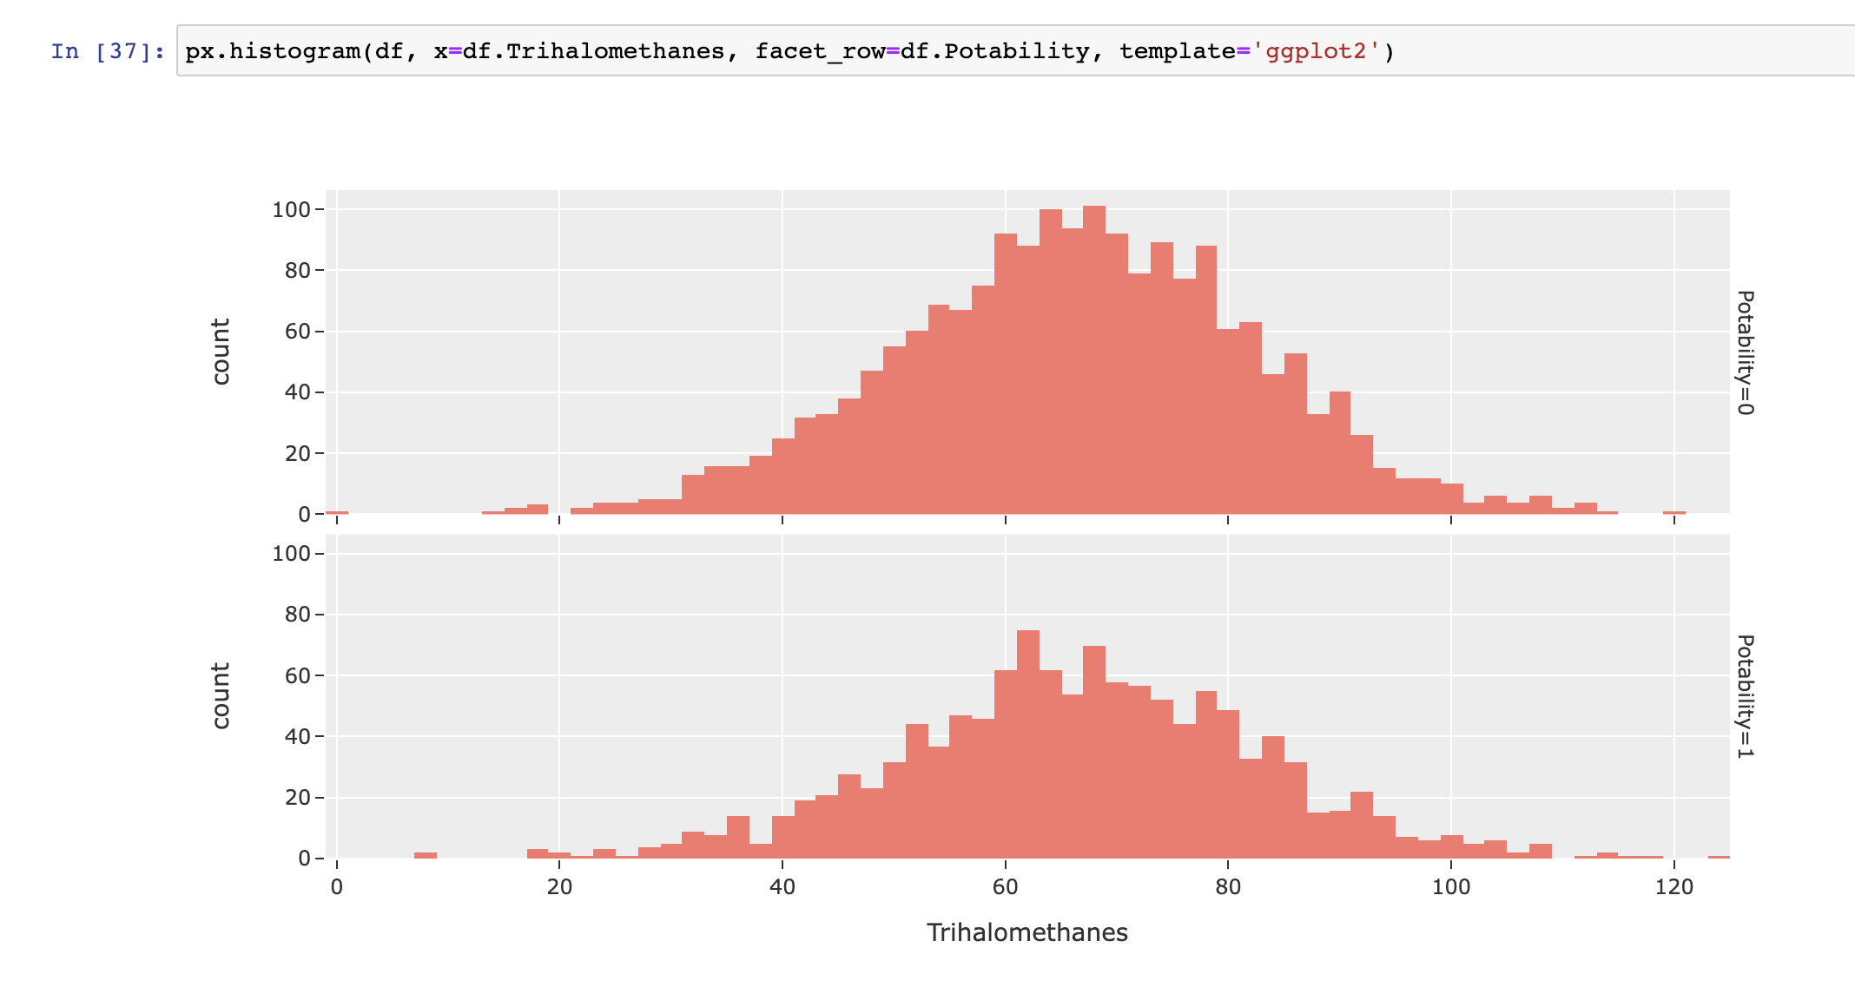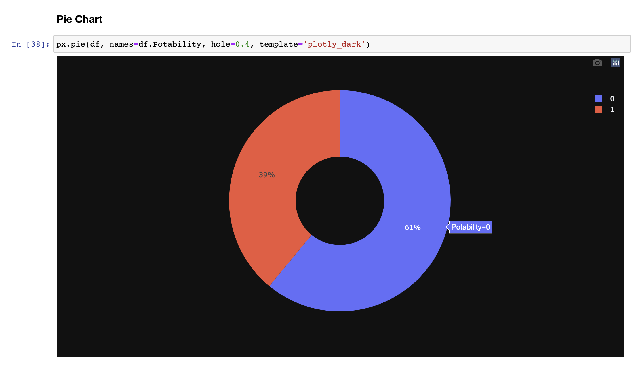

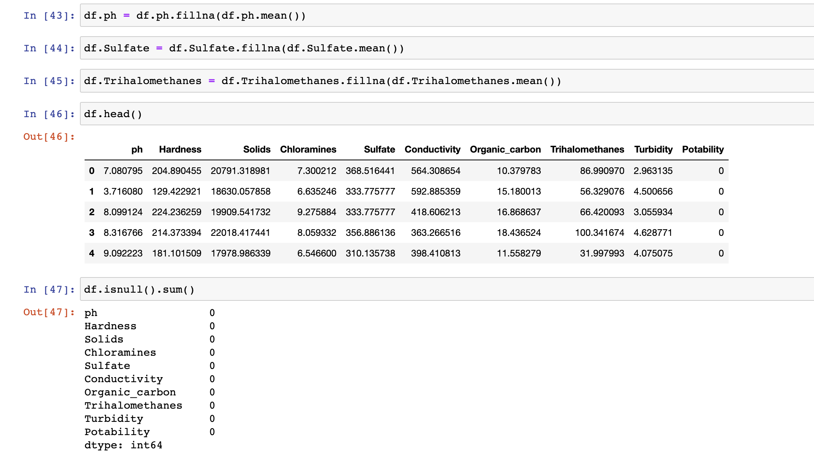

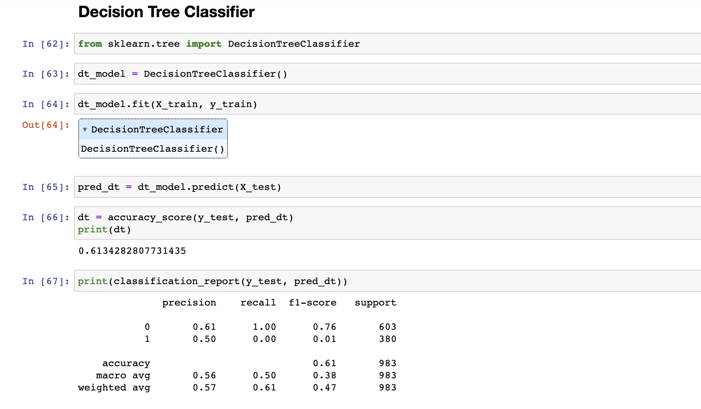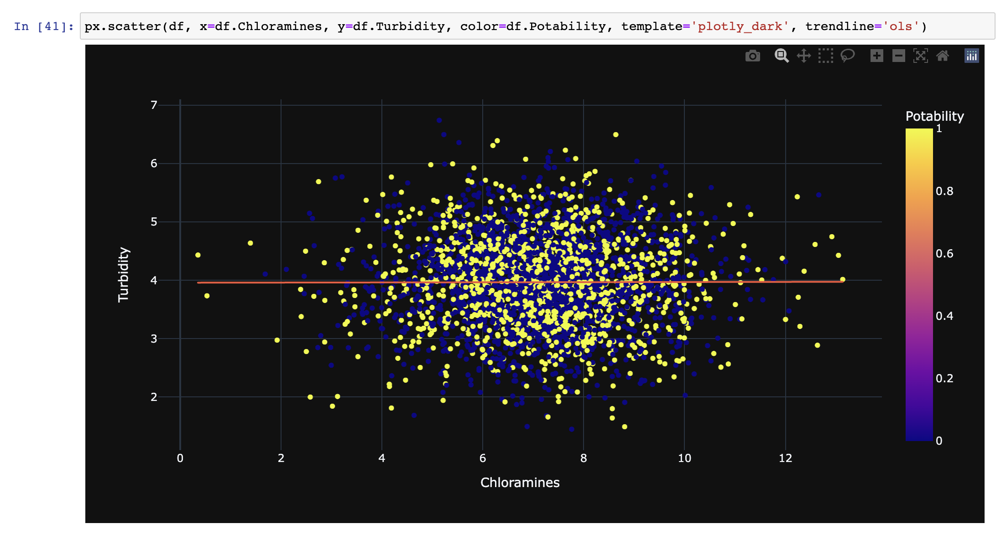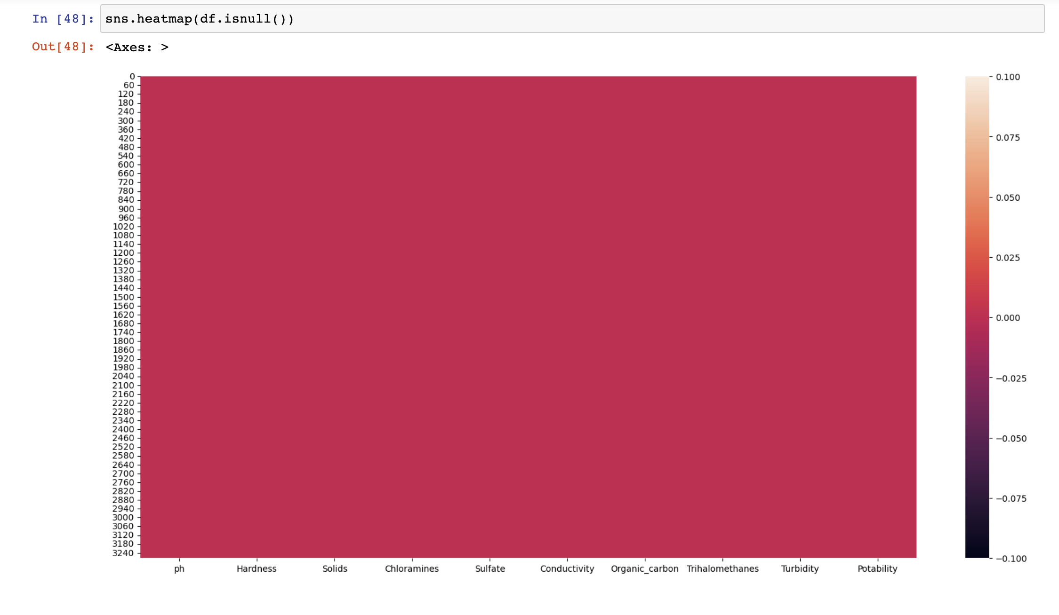

References -

1. Mathematics for Machine Learning, M. P. Deisenroth, A. A. Faisal & C. S. Ong, Cambridge University Press (2020)

2.Discovering Statistics Using R, A. Field, J. Miles & Z. Field, SAGE Publications (2012)

3.The Elements of Statistical Learning (2nd ed.), T. Hastie, R. Tibshirani & J. Friedman, Springer (2011) (+++)

4.Doing Data Science, C. O’Neill & R. Schutt, O’Reilly (2013)